What height is safe? An analysis of building destruction along the 207-km path of Nepal's 2026 flood
Nusrat Zahan Jarin¹, Obaidur Rahman², Rezwan Ahmed³
¹Department of Geography, University of California, Santa Barbara, CA, USA
²Department of Geography, Oklahoma State University, Stillwater, OK, USA
¹Department of Geography and Environment, University of Dhaka, Dhaka, Bangladesh
ORCID iD, Rezwan Ahmed: https://orcid.org/0009-0002-8003-099X
ORCID iD, Nusrat Zahan Jarin: https://orcid.org/0000-0003-2657-8559

Abstract
On 26 August 2026, a rock-ice avalanche from Langtang Lirung, Nepal, generated a flood that traveled 207 km down the Bhote Koshi–Trishuli valley, leaving 1,455 dead and 5,285 missing. Rapid satellite damage maps now appear within days of such disasters but are rarely reconciled or used to explain why some buildings were destroyed while neighbors survived, leaving no event-calibrated basis for deciding where rebuilding is unsafe. We asked how far the mapping products agreed, what controlled which buildings were destroyed, how the destructive reach of the flood changed downstream and how much warning time was available. We reconciled four rapid-mapping products and the government’s damage assessment into one building inventory and related it to pre-event terrain, Sentinel-2 surface change, flood-wave timing and five decades of settlement growth. The reconciled inventory records 5,781 damaged buildings, 4,530 of them destroyed. Height above the pre-event channel dominated a spatially cross-validated model of destruction (area under the receiver operating characteristic curve, AUC = 0.95). The height at which destruction became more likely than not fell from about 60 m in the gorge to about 7 m 110 km downstream, tracking independently mapped flow margins (Spearman ρ = 0.97). Built-up area less than 10 m above the channel had grown 17-fold since 1975. An automatic seismic alert could have given at least 30 minutes of warning for 73% of destroyed buildings, against 24% under the short message service (SMS) alert actually issued. Damage-calibrated heights offer an objective basis for danger zoning and warning in Himalayan valleys.
Keywords: cascading hazard; flood damage; Nepal; Bhote Koshi–Trishuli; height above the river; rapid damage mapping; early warning; recovery planning

1. Introduction
Cascading hazards that begin with a slope or glacier failure high in a mountain range and end as a flood far downstream are among the deadliest processes in High Mountain Asia (Kirschbaum et al., 2019; Mani et al., 2023). Recent examples include the 2021 Chamoli rock–ice avalanche in India (Shugar et al., 2021), the 2021 Melamchi flood (Chen et al., 2025; Maharjan et al., 2021) and the 2024 Thame outburst (Khadka et al., 2026) in Nepal, and the 2023 South Lhonak cascade in Sikkim (Sattar et al., 2025). Each overwhelmed settlements and hydropower assets that had been built in narrow valley floors, many tens of kilometers from the source. Glacier and permafrost change is altering the likelihood of such failures (R. Ahmed et al., 2026; Bashkova et al., 2026; Hock et al., 2019), while the population and infrastructure exposed to glacial floods and riverine hazards continue to grow (D. Li et al., 2022; Rentschler et al., 2023; Schwanghart et al., 2016; Taylor et al., 2023; Zheng et al., 2021).
Measuring the damage these floods cause remains difficult. Research on flood losses has long pointed to incomplete observations, uncertain asset values and the divergence of loss models (Gerl et al., 2016; Merz et al., 2010), problems that are most acute in data-scarce mountain regions (Romali et al., 2025). Cascading floods add a further complication, because damage develops through the interaction of a moving, sediment-laden flow with the valley it passes through (Chen et al., 2025; Cook et al., 2018), so that its pattern can change markedly from one reach to the next.
At 08:37 Nepal Time (NPT) on 26 August 2026, bedrock and part of a hanging glacier failed on the north face of Langtang Lirung at about 5,200 m above sea level (ICIMOD, 2026; Liu et al., 2026; Roy et al., 2026). Estimates of the failed volume range from 99 ± 10 × 10⁶ m³ (Roy et al., 2026) to about 132 × 10⁶ m³ (ICIMOD, 2026). The mass struck the Lhende glacier, briefly dammed the Lhende Khola and released a debris-laden flood that reached the Nepal–China border at Rasuwagadhi within about seven minutes and the confluence with the Kali Gandaki at Devghat, 207 km from the source, in the afternoon (CHWRR, 2026; NDRRMA, 2026). By 3 October, Nepal's National Disaster Risk Reduction and Management Authority (NDRRMA) had recorded 1,455 deaths and 5,285 people missing; Chinese authorities reported 43 deaths and 519 missing at Gyirong (Kyirong) port (ICIMOD, 2026; NDRRMA, 2026). The government's Rapid Damage and Needs Assessment (RDNA) estimated US$1.81 billion of physical damage, US$2.70 billion of total effects (6.7% of gross domestic product) and US$4.77 billion of recovery needs (NDRRMA & NPC, 2026). The consequences extended well beyond buildings: about 10,000 households needed immediate relief, three health posts were fully damaged, one hospital was partly damaged and access to two hospitals was cut, while damaged water and sanitation systems raised further public-health concerns (WHO, 2026). The event followed a supraglacial-lake outburst in July 2025 that had already damaged the same border crossing and hydropower plants (Q. Xu et al., 2026; Zhang et al., 2026).
Within days, the disaster had been mapped by several independent systems: the Copernicus Emergency Management Service (CEMS) (Copernicus EMS, 2026a, 2026b), the United Nations Satellite Centre (UNOSAT) (UNOSAT, 2026), the Humanitarian OpenStreetMap Team (HOT) (HOT, 2026), the United Nations Development Programme (UNDP) (UNDP, 2026) and the World Bank (World Bank & GFDRR, 2026), alongside the government's RDNA. An early analysis of the first rapid maps counted 695 destroyed building points and 15.7 km of destroyed road (R. Li, 2026).
Such rapid products are indispensable when valleys are cut off (Voigt et al., 2016), but they differ in imagery, coverage, damage scales and purpose, and their reported totals for this event ranged from fewer than 1,000 to more than 12,000 buildings depending on what was counted (R. Li, 2026; Liu et al., 2026; NDRRMA & NPC, 2026). They are rarely reconciled, and even more rarely used to ask why particular buildings were destroyed while neighbors survived. That question now matters for recovery. The government has announced that settlements in high-risk parts of the corridor will be relocated (Radio Nepal, 2026), but no event-calibrated, physically grounded basis yet exists for deciding where reconstruction is unsafe, and the warning of 26 August reached many riverside communities only after the flood had passed (Acharya, 2026; ICIMOD, 2026; C. Xu, 2026).
This study reconciles the building-damage records of four mapping products and the RDNA into a single corridor-scale inventory, and relates it to the pre-event terrain, to Sentinel-2 surface change, to the documented propagation of the flood wave and to five decades of settlement growth. It asks four questions. How much damage did the products record, and how far do they agree? What controlled which buildings were destroyed? How did the destructive reach of the flood change downstream? And how much warning time was available, and how was it used? Empirical vulnerability models relate building damage to the depth, velocity and impact pressure of the flow (Fuchs et al., 2007; Jakob et al., 2012; Prieto et al., 2018), but these cannot be observed for most buildings after an event of this kind. We therefore test whether height above the pre-event river channel, which can be computed for every building from a pre-event elevation model, explains destruction better than distance from the river, and whether the height reached by destruction changes downstream as the valley widens and the flood wave slows. Finally, we translate the results into municipality-level priorities for inspection, debris clearance, danger-zone mapping and early warning.

2. Data and Methodology

2.1 Study area
The study area comprises the corridor followed by the flood from the failure on the north face of Langtang Lirung to the confluence of the Trishuli and Kali Gandaki rivers at Devghat (Figure 1; the full corridor is mapped in Section 3.1). Measured along the traced flow path, the flood descended the Lhende Khola to the Nepal–China border at Rasuwagadhi (23 km from the source), followed the Bhote Koshi past Timure to Syaphrubesi (38 km), where the river becomes the Trishuli, and passed Betrawati (69 km), Trishuli Bazar–Bidur (78 km), Galchhi (106 km), Benighat (129 km) and Mugling (170 km) before reaching Devghat (206.8 km). Over this distance the channel falls from about 5,050 m to 180 m above sea level. More than 3,300 m of this drop occurs before the border; between Rasuwagadhi and Syaphrubesi the river runs through a narrow gorge in which the valley floor less than 20 m above the river is typically about 100 m wide, whereas below Betrawati it is about 260 m wide.
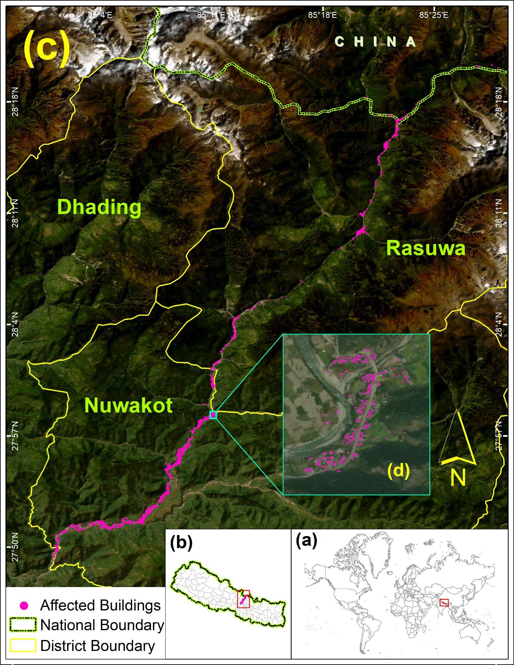
Figure 1. Location of the study area. (a) Location of Nepal. (b) Nepal and its districts, with the study area outlined in red. (c) The Bhote Koshi–Trishuli corridor in Rasuwa, Nuwakot and Dhading districts, with buildings recorded as affected by the 26 August 2026 flood (magenta). (d) Enlarged view of the area marked in (c).
The flood affected Rasuwa, Nuwakot, Dhading and Chitwan districts in Bagmati Province and Gorkha and Tanahun districts in Gandaki Province, and the government declared 15 municipalities disaster-affected areas for three months (WHO, 2026). The corridor carries the road to the Rasuwagadhi border crossing, a major trade route between Nepal and China, and a chain of hydropower plants (Liu et al., 2026); 13 hydropower projects with a combined capacity of 759 MW were affected (NDRRMA & NPC, 2026). In 2026 about 115,000 people lived within 1 km of the river along the corridor, and the September 2026 Overture Maps release contained 113,533 building footprints within 2 km of it (Overture Maps Foundation, 2026; WorldPop, 2025).

2.2 Data
We assembled every openly accessible building-damage record for the event, together with official reports, terrain, imagery, settlement and population data (Table 1). All sources were retrieved between 9 September and 20 October 2026 and archived with retrieval logs and Secure Hash Algorithm (SHA-256) checksums. Damage records comprised (i) the HOT inventory of 1,053 OpenStreetMap footprints graded as no damage, minor, major or destroyed, with an analyzed-area polygon (HOT, 2026); (ii) the latest CEMS grading products for the four areas of interest (AOIs) that were graded (AOI01 Syapru Besi, AOI02 Timure, AOI03 Bidur and AOI05 Phosretar), comprising 4,685 building points graded as possibly damaged, damaged or destroyed, with area-of-interest polygons, not-analyzed areas, imagery metadata and per-area statistics (Copernicus EMS, 2026a, 2026b); and (iii) the building-debris service of RAPIDA, UNDP’s satellite-based rapid crisis assessment tool, which re-published 3,043 footprints attributed to CEMS (2,311), the Service Régional de Traitement d’Image et de Télédétection (SERTIT; 48) and UNOSAT (684) (UNDP, 2026). The UNOSAT flow-extent polygon (37.35 km² within a 363 km² analyzed area) was used as an independent observation of the flood footprint (UNOSAT, 2026). Official information came from the NDRRMA situation reports and consolidated update to 3 October 2026 (NDRRMA, 2026), the RDNA (NDRRMA & NPC, 2026) and the propagation timeline of the Centre of Hydrology and Water Resources Research (CHWRR, 2026).
Building stock was derived from the Overture Maps release 2026-09-23.1 (Overture Maps Foundation, 2026), which conflates OpenStreetMap (Haklay & Weber, 2008), Google Open Buildings (Sirko et al., 2021) and Microsoft footprints; we retained 113,533 footprints within 2 km of the channel. Terrain came from the Copernicus GLO-30 digital elevation model (DEM; European Space Agency & Airbus, 2022), settlement history from the Global Human Settlement Layer built-up surface grid (GHS-BUILT-S) R2023A (1975–2020, 100 m) (Pesaresi, 2023; Pesaresi et al., 2024), population from WorldPop Global2 R2025A constrained counts for 2015, 2020 and 2026 (Stevens et al., 2015; WorldPop, 2025), land cover from the European Space Agency (ESA) WorldCover 2021 (Zanaga et al., 2022), infrastructure from Overture transportation and base themes, administrative boundaries from geoBoundaries (Runfola et al., 2020) and imagery from Sentinel-2 Level-2A (Drusch et al., 2012; Element 84, 2026).
Table 1. Data used in this study.
Dataset | Provider and version | Date and temporal resolution | Resolution or unit | Use in this study
HOT building-damage inventory and analyzed area | Humanitarian OpenStreetMap Team; AI-assisted (fAIR) labels on OpenStreetMap footprints | Post-event imagery; acquisition times not published; single post-event inventory | 1,053 footprints; 13.9 km² analyzed area | Damage labels (local models, harmonization)
CEMS EMSR927 grading | Copernicus EMS Rapid Mapping; AOI01, AOI02 first products; AOI03, AOI05 monitoring products (MONIT01) | Imagery 27 Aug–5 Sep 2026; one graded snapshot per AOI (latest product used) | Building points; road lines; bridge points; not-analyzed areas | Damage labels, graded domain, road and bridge damage
UNDP RAPIDA building debris layer | UNDP; records attributed to CEMS (2,311), SERTIT (48), UNOSAT (684) | StoryMap of 27 Aug, updated 2 Sep 2026; event-based updates, snapshot retrieved 9 Sep 2026 | 3,043 footprints with floors, site type, debris | Damage labels, debris model
UNDP RAPIDA economic estimate and affected population | UNDP (CLIMADA-based) | Reference date 31 Aug 2026; single estimate | Local-level US$ and people | Monetary comparison; affected-people indicator
UNOSAT flow extent FL20260826NPL | UNITAR/UNOSAT via UNESCO IHP-WINS | Imagery 26–27 Aug 2026; single post-event extent | 37.35 km² polygon in a 363 km² analyzed area | Flow-edge heights, exposure
NDRRMA situation reports and consolidated update | Government of Nepal | 26 Aug–3 Oct 2026; near-daily situation reports | Deaths, missing, warning timeline | Casualties, alert times
Rapid Damage and Needs Assessment (RDNA) | NDRRMA and National Planning Commission | 10 Sep 2026; single assessment | Affected buildings by local level; sector damage and needs | Comparison, ranking, monetary scope
Propagation timeline and gauge records | Centre of Hydrology and Water Resources Research (CHWRR) | 26 Aug 2026; event times to the nearest minute | Gauge-loss and threshold times; stage | Wave timing, stage rises
Rapid Hazard Assessment NP3 | HiRISK | 28 Aug 2026; single report | Source coordinates and process interpretation | Start of the traced flow path
Copernicus GLO-30 DEM | ESA/Airbus; tiles N27–N28, E084–E085 | Data acquired 2011–2015; single static epoch | 30 m | Flow path, height above channel, slope, transects
Sentinel-2 Level-2A | ESA Copernicus; Earth Search v1 cloud-optimized GeoTIFFs | 2025-10-11 to 2025-10-26 (14 scenes); 2026-09-21 to 2026-10-18 (19 scenes); 5-day revisit, combined into one pre-event and one post-event composite | 10–20 m | Change indices, true-color chips
Overture Maps release 2026-09-23.1 | Overture Maps Foundation; buildings, transportation, base (infrastructure, water) | Release 23 Sep 2026; monthly releases, one used | Footprints, lines, points | Common building stock; infrastructure exposure
GHS-BUILT-S R2023A | European Commission JRC | 1975–2020, 5-year epochs | 100 m | Built-up growth by height band
WorldPop Global2 R2025A constrained counts | WorldPop, University of Southampton | 2015, 2020, 2026; annual series (2015–2030), three years used | 100 m | Population in zones
geoBoundaries gbOpen NPL ADM3 | William & Mary geoLab (commit 9469f09) | Current release; static | Local-level polygons | Assignment to local levels
Seismic onset of the failure | NRSC/ISRO; USGS event us7000tbwb | 26 Aug 2026, 08:37:10 NPT; single time, to the nearest second | Time | Time zero of the propagation timeline
ESA WorldCover 2021 v200 | European Space Agency | 2021; single epoch | 10 m | Pre-event land cover in the flow extent
Note: Retrieval dates, URLs and checksums of every source are recorded in the accompanying retrieval logs; access terms are listed in Supplementary Table 1. Abbreviations not defined in the text: AI, artificial intelligence; ADM3, third-level administrative units (local levels); CLIMADA, CLIMate ADAptation risk-modeling platform; EMSR927, CEMS activation number; IHP-WINS, Water Information Network System of the UNESCO Intergovernmental Hydrological Programme; ISRO, Indian Space Research Organisation; JRC, Joint Research Centre; NRSC, National Remote Sensing Centre; UNESCO, United Nations Educational, Scientific and Cultural Organization; UNITAR, United Nations Institute for Training and Research; USGS, United States Geological Survey.

2.3 Damage analysis
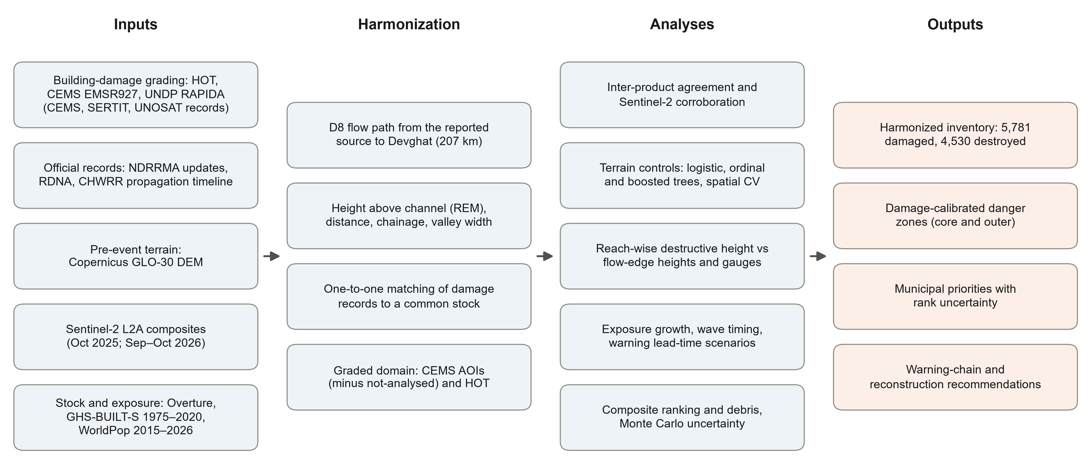
Figure 2. Workflow of the study: inputs, harmonization steps, analyses and outputs. All steps are scripted and rebuilt from the archived inputs by a single command.

2.3.1 Harmonizing the damage records
Figure 2 summarizes the workflow, from the harmonization of damage records and terrain processing to the analyses and their outputs. All records were matched to the common building stock. Each UNDP footprint was assigned to the stock polygon with which it shared the largest overlap; each HOT footprint was matched greedily by decreasing overlap, with at most one HOT footprint per stock polygon; and each CEMS point was matched greedily by increasing distance (zero inside a footprint, maximum 10 m) with at most one point per footprint. Records without a match (521 UNDP footprints, 363 HOT footprints and 631 CEMS points, many of them destroyed buildings deleted from OpenStreetMap after the event) were added to the stock as separate buildings, so that no damage record was lost; the common stock comprised 115,048 buildings. Damage grades were mapped to a common ordinal scale (none; minor or possibly damaged; major or damaged; destroyed), and each building took the most severe grade recorded by any product. Inter-product agreement was measured with Cohen's κ (Cohen, 1960) on the 867 buildings graded by both HOT and CEMS (CEMS AOI01 and AOI02). Because CEMS and UNDP list only damaged buildings, a building was treated as graded-undamaged only if it lay inside a CEMS area of interest and outside its not-analyzed areas, or if it carried a HOT label; statistical models were restricted to this graded domain (23,453 buildings within 1 km of the channel). HOT confidence scores and a 5-m translation of all HOT footprints were used to check the sensitivity of the local labels and of their overlap with the flow extent (Supplementary Fig. 6 and Supplementary Note 2).

2.3.2 Flow path and height above the river
The four GLO-30 tiles covering 84.3–85.7° E and 27.6–28.5° N were mosaicked and reprojected by bilinear interpolation to a 30-m grid in World Geodetic System 1984 (WGS 84) / Universal Transverse Mercator (UTM) zone 45N. The elevation model was hydrologically conditioned with the Priority-Flood+ε algorithm (Barnes et al., 2014), which guarantees that every cell drains to the grid edge, and deterministic eight-direction (D8) flow directions (O'Callaghan & Mark, 1984) and flow accumulation were computed. The flow path was traced downstream from the source coordinates reported by HiRISK (28.2887° N, 85.5282° E) (Liu et al., 2026) to the Trishuli–Kali Gandaki confluence at Devghat, a distance of 206.8 km. The path passed within 0.6 km of every reference settlement and its flow accumulation increased at the confluences of the Budhi Gandaki and Marsyangdi, confirming that it followed the main channel. Channel elevations along the path were made non-increasing downstream by a cumulative minimum, smoothed with an 11-cell running mean and constrained again, which removes artifacts from bridges and vegetation in the surface model.
Height above the channel (relative elevation) was computed for every cell within 6 km of the path as the cell elevation minus the inverse-distance-weighted (power 2) mean of the 16 nearest channel elevations (Garousi‐Nejad et al., 2019; Nobre et al., 2011; Rennó et al., 2008). It measures how far a building stands above the pre-event river, not the depth of the flow. For each building we also computed distance to the channel, distance downstream (chainage), the bank side and whether the building lay on the outer bank of a bend (from the signed curvature of the smoothed path over ±300 m), the local hillslope gradient, the channel gradient over a 2-km window and the width of the valley floor below 20 m relative elevation along a transect perpendicular to the path. The same transects, spaced every 90 m, were intersected with the UNOSAT flow extent to obtain the height of its outer edge on each bank.

2.3.3 Statistical and machine-learning models
For the HOT inventory, the probability of destruction was modeled by logistic regression on height above the channel, and 95% confidence bands and the height at 50% probability were obtained from 1,000 bootstrap resamples of 1-km reaches, which preserves spatial dependence (Efron & Tibshirani, 1993; Künsch, 1989). A multivariable logistic model and a proportional-odds ordinal model of the four HOT classes (Seabold & Perktold, 2010) included height (per 10 m), log distance, chainage, valley-floor width, outer-bank position, hillslope gradient, log footprint area and building density, with standard errors clustered by 1-km reach.
For the graded domain, we fitted histogram-based gradient-boosted trees (400 iterations, learning rate 0.05, 31 leaves, minimum 40 samples per leaf, L2 regularization 1) (Friedman, 2001; Pedregosa et al., 2011) to predict destruction from nine terrain and building attributes. Performance was estimated by six-fold cross-validation grouped by 5-km reaches, so that test buildings were spatially separated from training buildings (Meyer & Pebesma, 2022; Ploton et al., 2020; Roberts et al., 2017) and compared with logistic models using all attributes or height alone. Variable importance was the mean decrease in test-fold area under the receiver operating characteristic curve (AUC) over ten permutations (Fisher et al., 2019; Hooker et al., 2021; Strobl et al., 2007). Two further tests examined dependence on the labels: a model trained and cross-validated on CEMS labels alone within CEMS areas, and a model trained on all labels outside the HOT reach (21.4–41.5 km) and evaluated against HOT's independent labels (Supplementary Note 3).

2.3.4 Damage-calibrated destructive height
The damage-calibrated destructive height was estimated separately for 12 reaches of 5–7 km within the graded areas, as the height at which a logistic model of destruction on height above the channel reached 50% probability, with 500 block-bootstrap resamples of 0.5-km reaches. Where the bootstrap interval exceeded 60 m, we used the smaller of this estimate and the 90th percentile height of destroyed buildings. Reach estimates were smoothed with a three-reach running median within each contiguous graded segment to suppress single-reach outliers caused by a few up-slope records; an outer envelope used the 90th percentile height of destroyed buildings smoothed in the same way. Downstream of the last graded reach, the envelope was interpolated linearly between the stage rises recorded or reconstructed at Galchhi (8.9 m) (ICIMOD, 2026), Kali Khola (12.3 m maximum against a normal level of about 3.2 m) and Devghat (6.57 m against about 4 m) (CHWRR, 2026). Agreement with the UNOSAT flow-edge height (median of both banks within each reach) was measured by Spearman's rank correlation (Supplementary Note 4).

2.4 Population exposure
GHS-BUILT-S and WorldPop grids were interpolated to the 30-m grid by assigning each fine cell the density of its source cell, which preserves totals. Combining multi-temporal settlement and population layers in this way follows geographic information system (GIS) and remote-sensing approaches for tracking how flood exposure changes over time (R. Ahmed et al., 2024; Tellman et al., 2021). Built-up surface and population were summed within the UNOSAT flow extent and within bands of height above the channel within 1 km of the path. Two danger zones were then defined from the damage-calibrated heights: a core zone below the reach-wise 50%-destruction height and within 500 m of the channel, and an outer zone below the height that bounded 90% of destroyed buildings. Buildings, surviving buildings and residents in 2026 were counted in each zone. Pre-event land cover inside the flow extent was taken from ESA WorldCover 2021 (10 m) (Zanaga et al., 2022). Roads, bridges and power assets inside the flow extent were taken from Overture; damaged road lengths and bridge counts graded by CEMS are reported separately (Supplementary Table 13) because they are observations rather than exposure.

2.5 Satellite corroboration, warning lead time and recovery analyses

2.5.1 Sentinel-2 corroboration
Medium-resolution Copernicus imagery can detect building damage in many disasters despite its 10-m resolution, although models trained on past events transfer imperfectly to new ones (Dietrich et al., 2026). We therefore used Sentinel-2 not to grade buildings but to test the labels independently. Clear-sky median composites were built at 20 m from all Sentinel-2 Level-2A scenes with less than 70% cloud cover acquired in October 2025 (pre-event, after the July 2025 flood; 14 scenes) and between 21 September and 18 October 2026 (post-event; 19 scenes), keeping only pixels classed as vegetation, bare soil, water or unclassified in the scene classification layer (Drusch et al., 2012; Element 84, 2026). Reflectance was computed with each scene's scale factor; the processing-baseline offset listed in the metadata was applied only where the archive had not already removed it, and reflectance was clipped at 10⁻⁴ before computing visible brightness, the normalized difference vegetation index, the bare soil index and the normalized difference water index. Where an acquisition had been processed twice, only the later processing was used (Supplementary Note 5). Composites were built per Military Grid Reference System (MGRS) tile and mosaicked by the larger number of clear observations. Post-minus-pre differences were averaged over a 3 × 3-pixel window around each building, and their ability to separate destroyed from undamaged buildings was measured by the AUC.

2.5.2 Wave timing and warning lead time
Arrival times of the wave front were assembled from the seismic failure time and the CHWRR timeline (Supplementary Table 2) and interpolated linearly along the channel. Gauge-loss times are upper bounds on arrival. Lead time for each destroyed building was the interpolated arrival time minus the alert time under three scenarios: the mass short message service (SMS) alert (09:15), the first telephone warnings (08:50, the midpoint of 08:46–08:54) and a counterfactual automatic alert two minutes after the seismic signal (08:39:10) (Supplementary Note 6).

2.5.3 Recovery priorities, debris and economic estimates
Indicators were assigned to local levels using geoBoundaries (Runfola et al., 2020) with spelling harmonized to the RDNA. The composite index combined six indicators: satellite-recorded destroyed buildings, RDNA-affected buildings, government-reported affected people (UNDP, 2026), modeled building debris and buildings and population in the core danger zone. In each of 20,000 Monte Carlo draws, weights were sampled from a flat Dirichlet distribution, indicators were normalized by min–max scaling, percentile ranks or logistic-transformed z-scores and aggregated arithmetically or geometrically; we report the median rank, its 5–95% interval and the probability of a top three rank (OECD et al., 2008; Saisana et al., 2005; Tate, 2012).
Building debris was estimated for the harmonized inventory with the UNDP model: floor area (footprint area × number of floors) × a grade coefficient (1.0, 0.5 and 0.05 t m⁻² for destroyed, damaged and possibly damaged buildings) × a settlement factor (3, 2 and 1 for urban, peri-urban and rural buildings) (UNDP, 2026). Floors and settlement type were taken from UNDP records where available; otherwise, floors were set to the mean for the settlement type and buildings with at least 40 neighbors within 100 m were treated as urban, a threshold calibrated on UNDP's classification. Uncertainty was explored with 5,000 draws in which grade coefficients were scaled by a common factor between 0.6 and 1.4 and the urban factor varied between 1 and 3 (Supplementary Fig. 5). Monetary estimates were not recomputed; we compare published estimates and state their scope.

2.5.4 Reproducibility
All analyses were run in Python 3.14 with NumPy, pandas, Shapely, rasterio, statsmodels (Seabold & Perktold, 2010) and scikit-learn (Pedregosa et al., 2011). The scripts, a one-command rebuild, retrieval logs and checksums accompany this document. Random seeds were fixed (20260826). No field survey was conducted, no new satellite classifier was trained, and no hydraulic simulation was performed.

3. Results

3.1 The flood and its 207-km impact corridor
The flood wave decelerated sharply as it traveled down the corridor (Figure 3a,b). Using the failure time recorded seismically (08:37:10 NPT) (Roy et al., 2026), the reported arrival at Rasuwagadhi and the times at which river gauges stopped transmitting or crossed warning levels (CHWRR, 2026), the front averaged 57 m s⁻¹ over the first 23 km, 36 m s⁻¹ to Syaphrubesi and 19 m s⁻¹ to Betrawati, before slowing to 6–9 m s⁻¹ along the Trishuli and 4 m s⁻¹ above Devghat (Supplementary Table 2). Peak discharge was reconstructed at about 17,000 m³ s⁻¹ at Galchhi (ICIMOD, 2026) and measured at 5,850 m³ s⁻¹ at Devghat (CHWRR, 2026). Damaged buildings were concentrated in two reaches: the confined gorge between Rasuwagadhi and Syaphrubesi (21–41 km from the source), and the wider Trishuli valley between Betrawati and Galchhi (64–114 km) (Figure 3c). The number of people reported dead rose steadily for a month after the event, while the number missing peaked in mid-September before falling to 5,285 (Figure 3d).
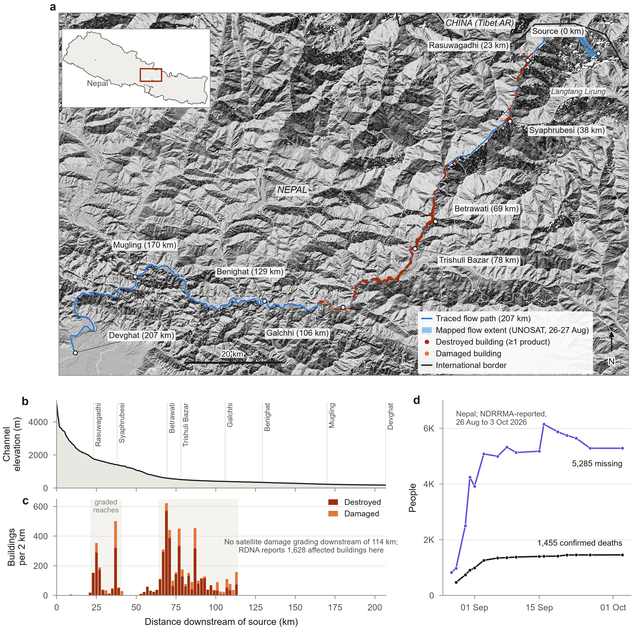
Figure 3. The 26 August 2026 flood and its 207-km impact corridor. (a) Shaded-relief map of the corridor from the failure on the north face of Langtang Lirung to the Trishuli–Kali Gandaki confluence at Devghat, showing the D8 flow path traced from the reported source, the UNOSAT flow extent mapped from imagery of 26–27 August, and buildings recorded as destroyed or damaged by at least one product. Distances are along the traced path. (b) Elevation of the channel along the path. (c) Damaged and destroyed buildings per 2 km of path; shading marks reaches graded by satellite products. (d) Deaths and missing people in Nepal reported by NDRRMA between 26 August and 3 October 2026. Map projection: WGS 84 / UTM zone 45N. Data: Copernicus DEM; UNOSAT; HOT; CEMS EMSR927; UNDP RAPIDA; NDRRMA.

3.2 Reconciling the damage record
The products that recorded this damage overlapped only partly (Figure 4a; Table 2). The CEMS photo-interpreted 17,299 buildings in four areas of interest using 0.3–1 m imagery acquired between 27 August and 5 September and graded 4,685 of them as affected (3,571 destroyed) (Copernicus EMS, 2026a). The HOT inventory graded 1,053 buildings in the upper corridor with an artificial-intelligence-assisted workflow (HOT, 2026), and the UNDP RAPIDA service re-published 3,043 damaged footprints attributed to CEMS, SERTIT and UNOSAT (UNDP, 2026). After one-to-one matching of points and footprints to a common stock of 115,048 buildings (Section 2.3.1), the products together recorded 5,781 damaged buildings, of which 4,530 were destroyed; 1,912 buildings were classed as destroyed by at least two products (Figure 4b). This harmonized total is 2.5 times the 2,359 records available to the first UNDP assessment, because later CEMS monitoring products extended grading to Kispang, Belkotgadhi and Galchhi (Supplementary Table 3).
Table 2. Damage evidence reconciled in this study.
Product | Provider and method | Imagery (2026) | Reach graded (km from source) | Buildings graded | Damaged | Destroyed
HOT inventory | HOT; AI-assisted (fAIR) labels on OpenStreetMap footprints | Post-event very-high-resolution (dates not documented) | 22–40 | 1,053 | 937 | 677
CEMS AOI01 Syapru Besi | Copernicus EMS; photo-interpretation (first product, v1) | WorldView-3 27 Aug | 35–38 | 559 | 433 | 323
CEMS AOI02 Timure | Copernicus EMS; photo-interpretation (first product, v2) | Legion 27 Aug | 23–27 | 441 | 431 | 372
CEMS AOI03 Bidur | Copernicus EMS; photo-interpretation (monitoring product, v1) | PeruSAT-1 27 Aug; Resurs-P 28 Aug | 65–88 | 11,486 | 3,058 | 2,479
CEMS AOI05 Phosretar | Copernicus EMS; photo-interpretation (monitoring product, v2) | Legion 5 Sep; Pleiades Neo 5 Sep | 89–114 | 4,813 | 763 | 397
UNDP RAPIDA service | UNDP; republished CEMS (2,311), SERTIT (48) and UNOSAT (684) records on Google footprints with debris model | As source products | 22–101 | – | 3,043 | 2,574
UNOSAT flow extent | UNOSAT; flow/mudflow extent (no building grading) | PlanetScope 26 Aug; Sentinel-2 27 Aug | 0–106 | – | – | –
Official RDNA | NDRRMA/NPC; satellite and drone imagery, fAIR-HOT mapping, Census 2021 typology | Various, to 3 Sep | 15 local levels | – | 7,570 (affected) | –
Harmonized union (this study) | One-to-one matching to Overture footprints; most severe grade | – | 0–114 | – | 5,781 | 4,530
Note: Counts refer to buildings within 2 km of the traced channel after matching. Imagery and dates are those reported by each provider. CEMS 'affected' combines possibly damaged, damaged and destroyed.
Where two products graded the same buildings, they agreed on destruction but not on lesser damage. Among 867 buildings graded by both HOT and CEMS, 97% of buildings that CEMS classed as destroyed were also destroyed in HOT, and 65% of HOT-destroyed buildings were destroyed in CEMS (Cohen's κ = 0.49) (Cohen, 1960), whereas the two products disagreed on most minor and major damage (Figure 4c and Supplementary Table 4). Only 34% of the 367 UNOSAT-attributed 'destroyed' records that fell inside CEMS areas were also destroyed in CEMS, indicating that records of unknown provenance should not be merged without checking. Sentinel-2 composites from the same season before and after the event, which no product used for building grading, independently corroborated the destruction labels. The loss of vegetation signal at building locations, consistent with sediment covering roofs, gardens and fields, separated destroyed from undamaged buildings with an AUC of 0.95 across all graded areas and 0.94 against HOT's labels (normalized difference vegetation index, NDVI; visible brightness gave 0.94). In the CEMS grading, the median NDVI change was +0.02 for buildings without damage, −0.03 for possibly damaged, −0.18 for damaged and −0.41 for destroyed buildings (Figure 4e,f, Supplementary Fig. 2 and Supplementary Table 5).
The satellite-graded counts matched the government's RDNA in the graded reaches (median ratio 1.16; Figure 4d), but not elsewhere. In local levels without satellite grading, most of them below Galchhi, the RDNA reported 1,797 affected buildings, including 1,037 in Benighat Rorang (NDRRMA & NPC, 2026). Yet only 33 buildings in Benighat Rorang lie within 10 m of the channel's elevation, and stage rises of about 9 m were recorded or reconstructed in this reach (CHWRR, 2026; ICIMOD, 2026). The RDNA counts therefore probably include buildings affected by proximity, erosion of slopes and roads, or service loss rather than direct flooding, and they are the clearest target for field verification.
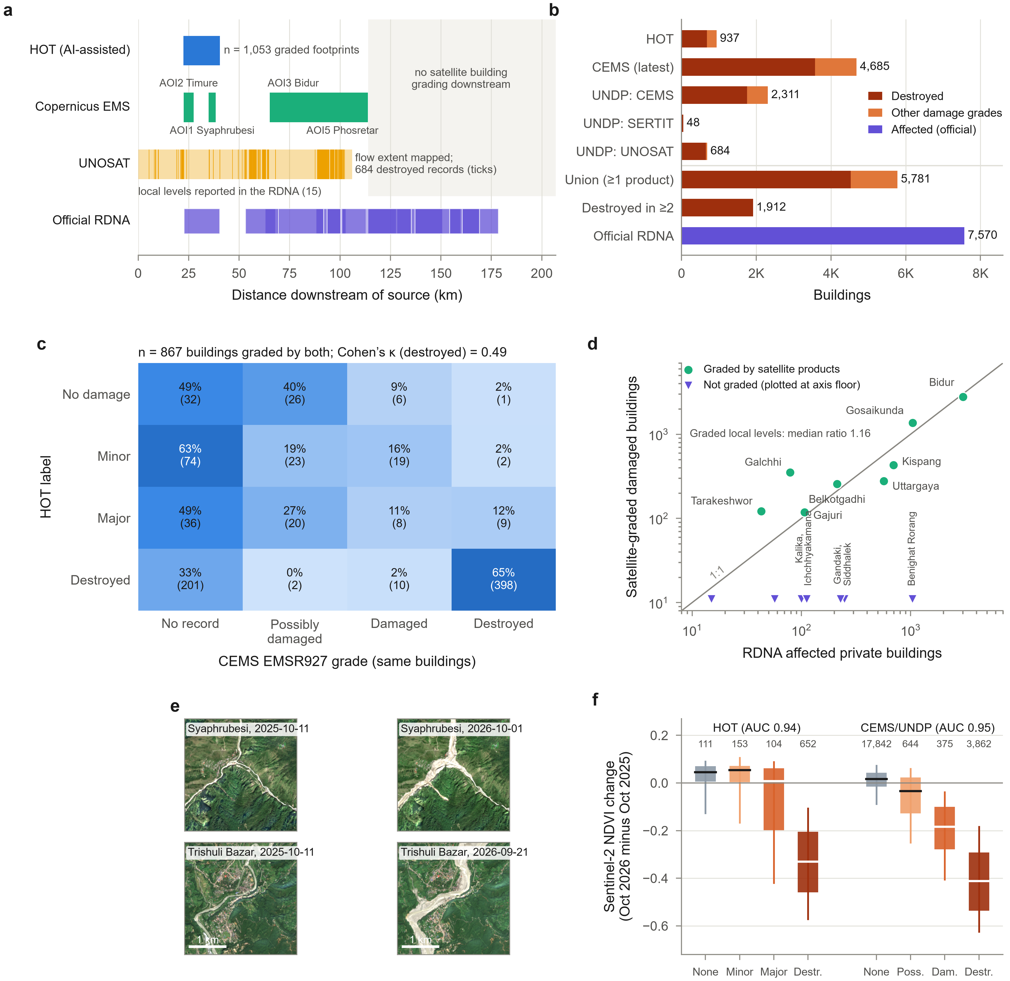
Figure 4. Reconciling the damage record. (a) Reaches graded by each product along the corridor and the local levels reported in the RDNA; ticks show individual UNOSAT-attributed records. (b) Buildings recorded as damaged by each product, by the harmonized union and by the RDNA. (c) Agreement between HOT and CEMS for the 867 buildings graded by both, as row percentages with counts. (d) Satellite-graded damaged buildings against RDNA-affected buildings by local level; local levels without satellite grading are plotted at the axis floor. (e) Sentinel-2 true-color images from the clearest pre-event (October 2025) and post-event (September–October 2026) scenes at Syaphrubesi (top) and Trishuli Bazar (bottom), with acquisition dates and the same reflectance stretch for all images. (f) Post-minus-pre change in NDVI at building locations by HOT grade and by CEMS/UNDP grade (boxes, interquartile range; whiskers, 10th–90th percentiles; numbers, buildings), with the AUC for separating destroyed from undamaged buildings within each set. Contains modified Copernicus Sentinel data (2025, 2026).

3.3 Height above the river governed destruction
Within the HOT inventory, the share of destroyed buildings fell from 95% for buildings less than 20 m above the channel to 7% for buildings more than 80 m above it, while the shares of minor damage and no damage rose (Figure 5c). Height above the pre-event channel — the relative elevation of each building above the traced flow path, similar to height above nearest drainage (Nobre et al., 2011; Rennó et al., 2008) — discriminated destroyed from surviving buildings with an AUC of 0.92; each additional 10 m of height halved the odds of destruction (odds ratio 0.50). Distance from the channel was a weaker discriminator (AUC 0.83). In an ordinal model of the four HOT damage classes with errors clustered by 1-km reach, height (odds ratio 0.85 per 10 m), distance, distance downstream and hillslope gradient were all associated with less severe damage, and buildings on the outer banks of bends had 1.5 times the odds of more severe damage (odds ratio 1.53, 95% confidence interval 1.07–2.17; Supplementary Table 6) — consistent with superelevation and erosion where flows impinge on the outside of bends.
Across the 23,453 buildings in all graded areas, a gradient-boosted classifier (Friedman, 2001; Pedregosa et al., 2011) trained on terrain and building attributes predicted destruction with an AUC of 0.95 under spatial block cross-validation (Ploton et al., 2020; Roberts et al., 2017) (precision–recall AUC 0.76 at a prevalence of 18%; Figure 5e and Supplementary Table 7). Height above the channel was by far the most important predictor: permuting it reduced the AUC by 0.20, against 0.045 for distance from the channel and 0.036 for distance downstream (Figure 5f and Supplementary Fig. 3) (Fisher et al., 2019). The result did not depend on which product supplied the labels: a model using CEMS labels alone achieved an AUC of 0.95, and a model trained outside the HOT reach predicted HOT's independent labels with an AUC of 0.89. Height alone retained an AUC of 0.86, but its effect differed strongly between reaches (Figure 5d), which motivated a reach-specific analysis.
The two zoomed maps in Figure 5 illustrate the contrast. At Timure, in the gorge, buildings were destroyed up to the upper limit of the valley floor, tens of meters above the river. At Trishuli Bazar–Bidur, destroyed buildings were confined to the lower river terraces, below about 20 m, while the town on the higher terrace survived almost intact (Figure 5a,b).
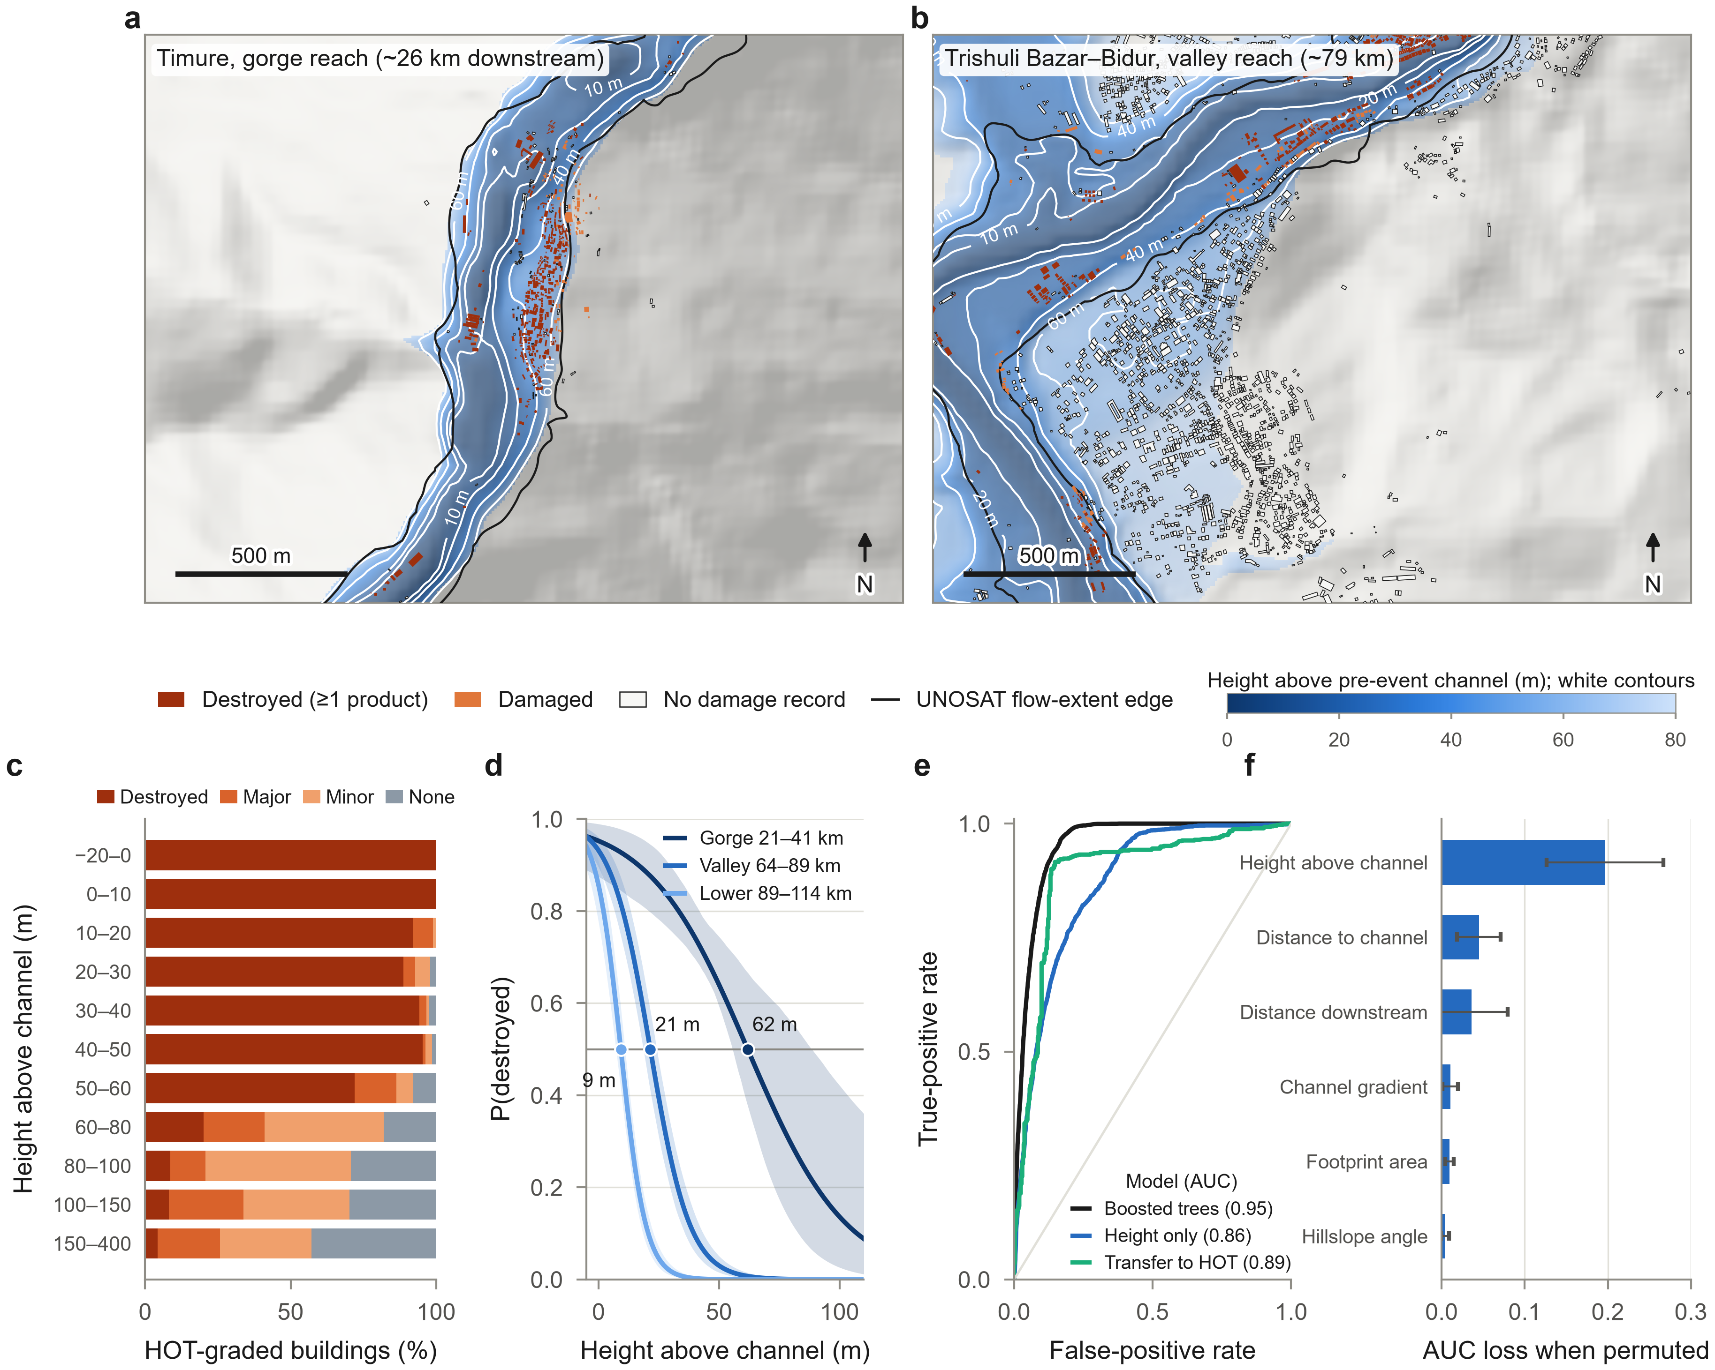
Figure 5. Height above the river governed destruction. (a, b) Height above the pre-event channel (shading and white contours), the UNOSAT flow-extent edge and building footprints colored by the most severe grade recorded, at Timure in the gorge (a) and Trishuli Bazar–Bidur in the valley (b). (c) Composition of HOT damage classes by height above the channel; numbers at right give buildings per band (Supplementary Table 6). (d) Probability of destruction against height above the channel for the three graded reach groups, with 95% block-bootstrap bands; dots mark the height at 50% probability. (e) Receiver-operating-characteristic curves for gradient-boosted trees under spatial cross-validation, for height alone, and for the model transferred to HOT labels. (f) Permutation importance (mean loss of AUC ± s.d. across folds).

3.4 A destructive height that declined downstream
We estimated, for each graded reach, the height above the channel at which the probability of destruction reached 50% (Section 2.3.4). This damage-calibrated height was 55–60 m in the gorge (all gorge buildings pooled: 62 (95% confidence interval [CI] 56–88) m), declined from 33 to 15 m between Betrawati and Bidur (pooled: 21 (95% CI 19–24) m) and was 7–12 m below Bidur (pooled: 9 (95% CI 7–11) m) (Figure 6a and Supplementary Table 8). It closely matched an independent measure — the height of the outer edge of the UNOSAT flow extent, mapped from imagery rather than from buildings — across all 11 reaches (Spearman ρ = 0.97; Figure 6d). Downstream of the last graded reach, stage rises recorded or reconstructed at Galchhi (about 9 m), Kali Khola (about 9 m) and Devghat (about 2.6 m) (CHWRR, 2026; ICIMOD, 2026) were consistent with the lowest damage-calibrated heights.
The downstream decline in destructive height paralleled the deceleration of the wave front from more than 50 m s⁻¹ to less than 10 m s⁻¹ and the widening of the valley floor from about 100 m in the gorge to more than 250 m below Betrawati (Figure 6b,c and Supplementary Fig. 4). In the gorge, destruction extended well beyond plausible water depths: only 16% of destroyed buildings lay less than 20 m above the channel, compared with 61% in the middle valley and 87% in the lower reach (Figure 6e). This pattern implicates the high momentum of a sediment-laden surge confined in a narrow valley, superelevation in bends and the collapse of undercut terraces, rather than inundation alone (Cook et al., 2018; Jakob et al., 2012; Papathoma-Köhle et al., 2017). It also means that a single setback distance or flood-mark height cannot define safe ground along the whole corridor (Supplementary Table 9).
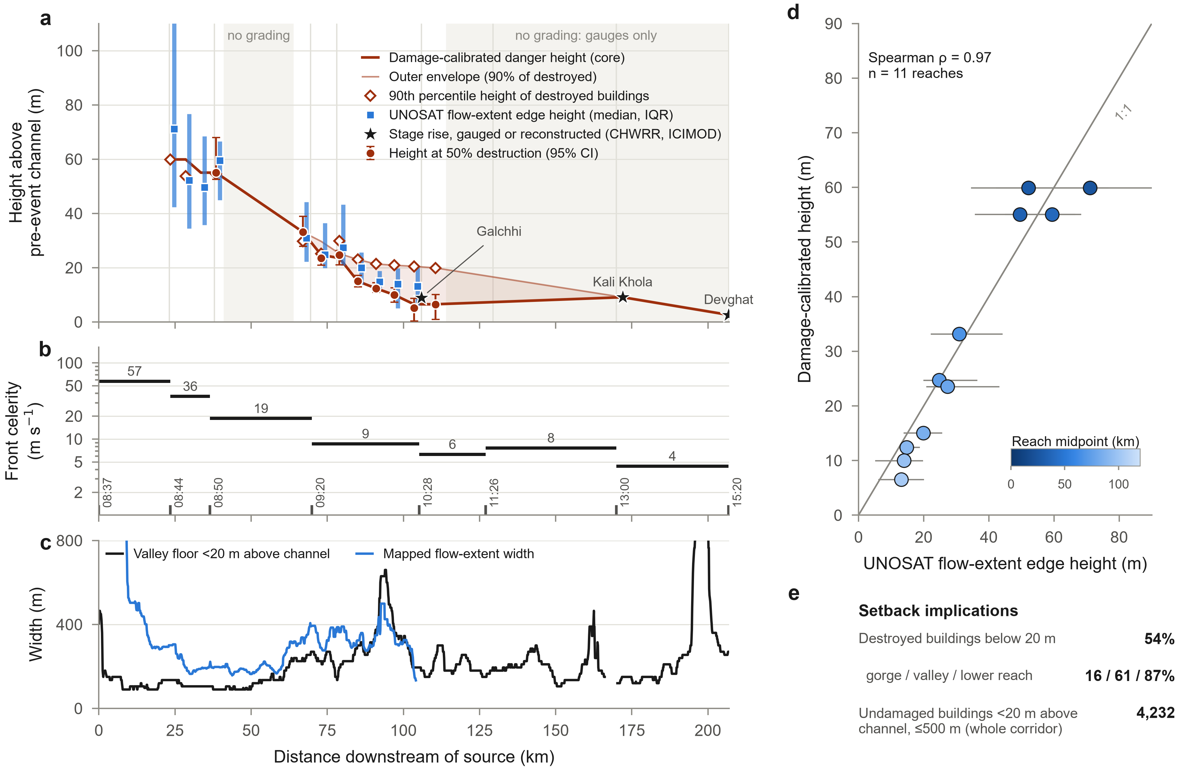
Figure 6. The destructive height declined downstream. (a) Damage-calibrated destructive height (height at 50% probability of destruction, with 95% intervals), 90th-percentile height of destroyed buildings, height of the UNOSAT flow-extent edge (median and interquartile range) and stage rises gauged or reconstructed downstream, with the core and outer envelopes used for the danger zones. (b) Mean celerity of the wave front between timed locations, with times (NPT). (c) Width of the valley floor less than 20 m above the channel and width of the mapped flow extent (running medians). (d) Damage-calibrated height against flow-extent edge height for the 11 graded reaches. (e) Shares of destroyed buildings below 20 m and the number of undamaged buildings below 20 m.

3.5 Settlement growth into the destruction zone
Built-up surface on the valley floor had expanded far faster than on higher ground (Figure 7a). Within 1 km of the channel in the graded corridor, built-up area less than 10 m above the channel grew 17-fold between 1975 and 2020, and that 10–20 m above the channel 13-fold, compared with 7.7-fold for land more than 80 m above it (Supplementary Table 10) (Pesaresi, 2023; Pesaresi et al., 2024). Inside the area later mapped as flow extent, built-up surface increased from 3.5 ha to 43.7 ha, consistent with an independent estimate (R. Li, 2026). At Trishuli Bazar–Bidur, much of the riverside building destroyed in 2026 had appeared since 2005 (Figure 7b). The pattern mirrors the faster growth of settlements in flood zones observed worldwide (Rentschler et al., 2023; Tellman et al., 2021) and in Nepal's road and hydropower corridors (McAdoo et al., 2018; Schwanghart et al., 2016). Before the event, the land later covered by the flow included 3.4 km² of cropland, 98% of it in the Trishuli valley, 1.0 km² of built-up land and 12.3 km² of tree cover (Supplementary Table 15) (Zanaga et al., 2022).
Applying the damage-calibrated height to the whole corridor identifies the ground that the 2026 event proved to be most hazardous. The core zone contained 4,868 buildings, of which 1,541 survived, and an estimated 6,100 residents in 2026 (WorldPop, 2025). It captured 73% of all destroyed buildings. The outer zone contained 7,415 buildings (3,377 surviving) and about 9,600 residents and captured 89% of destroyed buildings (Figure 8c). These zones are an evidence base, not a regulatory map, but they indicate the scale of the relocation and reconstruction decisions now facing local and national government (Radio Nepal, 2026).

3.6 Warning time was available for most destroyed buildings
The propagation record shows that warning time was short only in the uppermost reach (Figure 7c). The first official warnings were telephoned from Rasuwa between 08:46 and 08:54, requesting evacuation of residents up to 200 m above the riverbank, and the Department of Hydrology and Meteorology sent 679,295 SMS warnings at 09:15 (NDRRMA, 2026). By then the wave had passed Syaphrubesi and was approaching Betrawati. Interpolating arrival times along the channel, 29% of destroyed buildings were reached before the SMS was sent, and only 24% received it at least 30 minutes ahead of the flood (Figure 7d). Had an alert been issued automatically two minutes after the seismic signal, which exceeded magnitude 5 (Roy et al., 2026; Slaughter et al., 2026), no destroyed building would have been reached before the alert, and 73% would have had at least 30 minutes (median 41 min). Even so, the median warning in Gosaikunda would have been only 6 min, compared with 54 min in Bidur (Supplementary Table 11).
Mortality cannot yet be located — 57% of the bodies were recovered beyond the corridor, in Chitwan and Nawalparasi (NDRRMA, 2026), and the reported totals were still being revised in late September (Supplementary Table 12) — but the distribution of the missing is consistent with the warning gradient. Rasuwa district, where the flood arrived within minutes of the failure, recorded 3,514 missing people (2.6 per destroyed building in its local levels), whereas Nuwakot, reached 30–90 minutes after the failure, recorded 1,247 (0.4 per destroyed building). The difference also reflects the many travelers, pilgrims, customs officers and hydropower workers present at the border on the day of the disaster (NDRRMA, 2026).
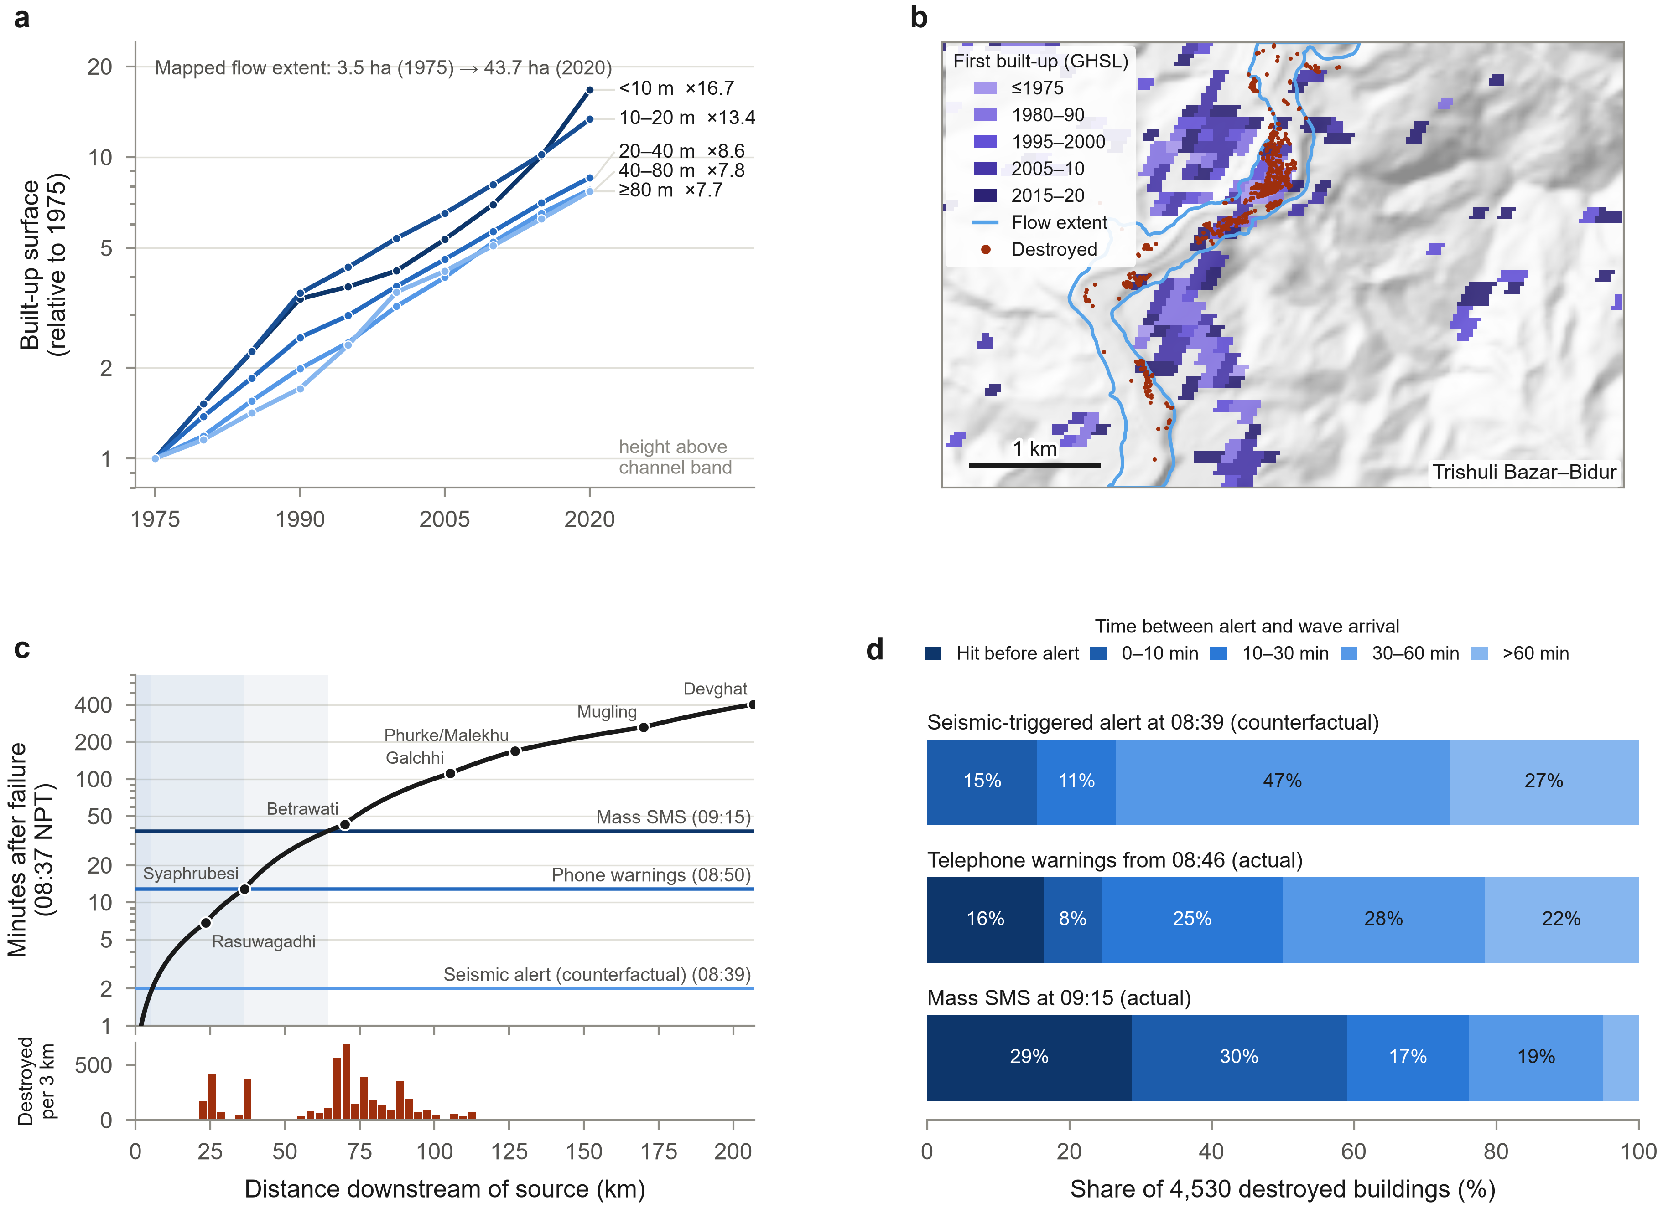
Figure 7. Exposure growth into the destructive zone and warning time. (a) Built-up surface within 1 km of the channel in the graded corridor, relative to 1975, by band of height above the channel (GHS-BUILT-S R2023A). (b) Epoch in which each 30-m cell first exceeded 10% built-up surface at Trishuli Bazar–Bidur, with the flow extent and destroyed buildings. (c) Arrival time of the wave front after the failure (log scale) along the corridor and the times of the counterfactual seismic-triggered alert, the first telephone warnings and the mass SMS; the lower panel shows destroyed buildings per 3 km. (d) Time between alert and wave arrival for the 4,530 destroyed buildings under the three alert scenarios.

3.7 Recovery priorities, debris and losses
The composite index combining satellite-recorded destruction, RDNA-affected buildings, government-reported affected people, modeled building debris and the buildings and population in the core danger zone placed Bidur and Gosaikunda first and second in almost every simulation (probability of a top-three rank 1.00 and 0.99), followed by Kispang (0.77) (Figure 8a,b, Table 3 and Supplementary Fig. 5c) (OECD et al., 2008; Saisana et al., 2005). Benighat Rorang ranked sixth on average but with the widest interval, reflecting the absence of satellite grading and the large RDNA count.
Building debris, modeled with the coefficients used by UNDP for the harmonized inventory, amounted to 1.04 million tons (90% range 0.44–1.22 million tons under uncertain material coefficients and settlement factors; Figure 8e and Supplementary Fig. 5a,b), roughly 1.9 times the first UNDP estimate (UNDP, 2026). Bidur accounted for 60% of this tonnage, but only 44% if the threefold multiplier applied to urban buildings is removed, so that clearance planning in Bidur depends strongly on an untested assumption. In its four areas of interest, CEMS also graded 73 km of road and 44 of 54 affected bridges as destroyed (Supplementary Table 13). The available monetary estimates differ by more than an order of magnitude because they measure different things (Figure 8d and Supplementary Table 14): modeled direct building damage (US$0.17 billion) (UNDP, 2026), private housing and household assets (US$0.42 billion), all physical damage (US$1.66–1.81 billion) (NDRRMA & NPC, 2026; World Bank & GFDRR, 2026), total effects (US$2.70 billion) and recovery needs (US$4.77 billion) (NDRRMA & NPC, 2026). Energy alone accounted for US$0.89 billion of damage, with 13 hydropower projects (759 MW) affected and about 431 MW of generation, roughly a tenth of national capacity, interrupted (NDRRMA & NPC, 2026).
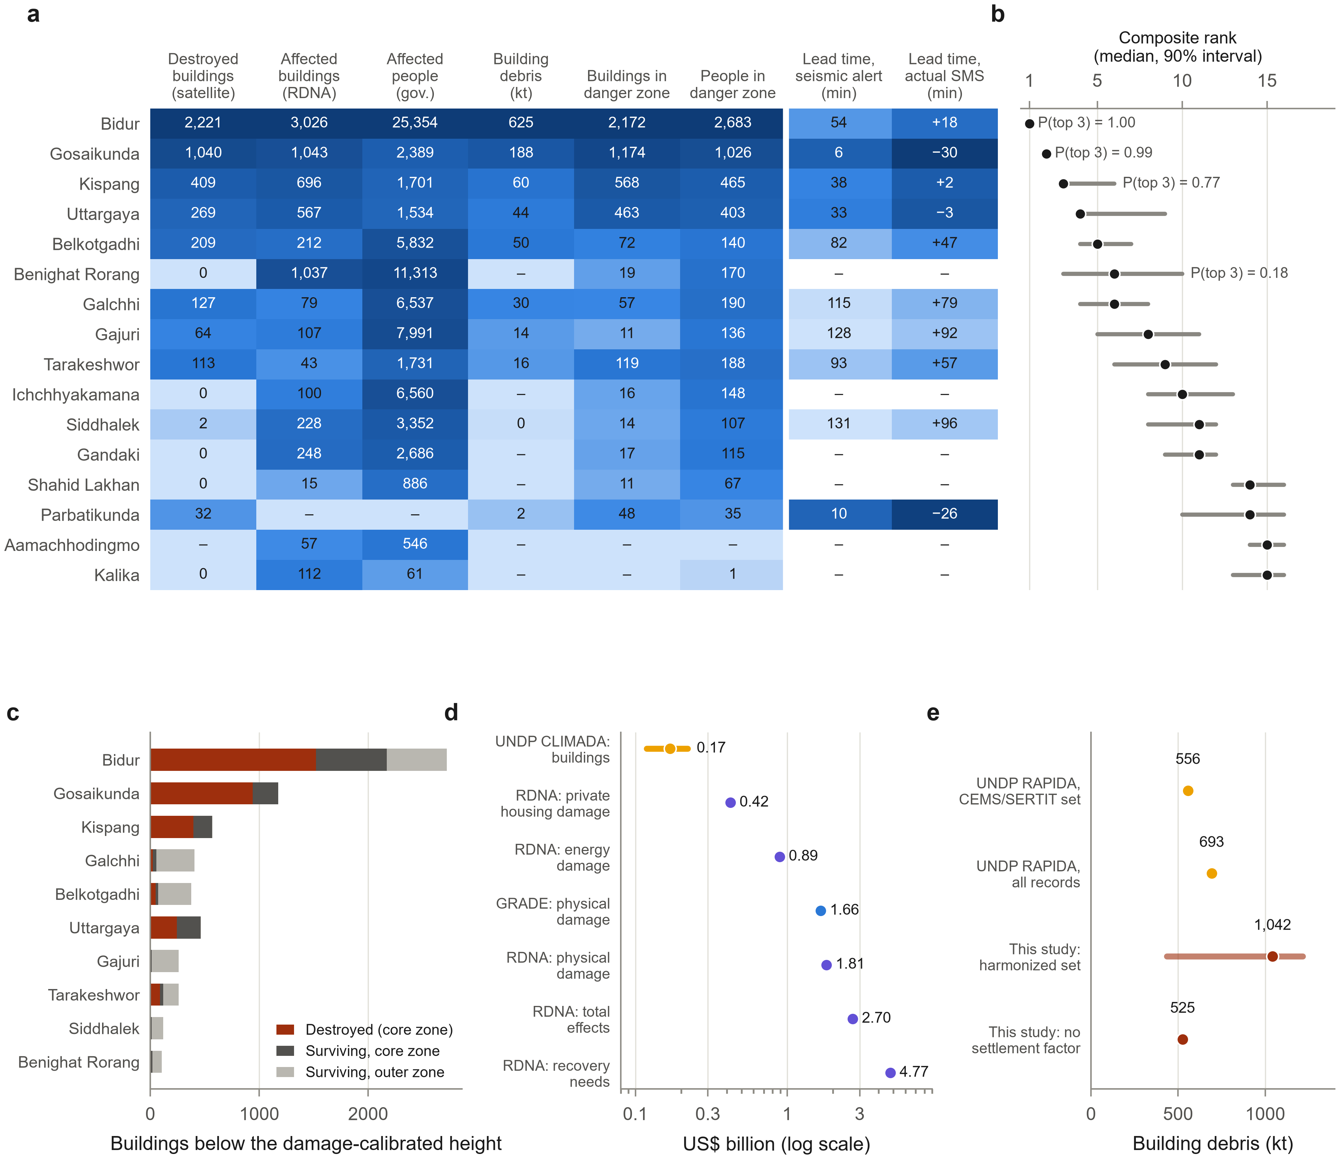
Figure 8. Recovery priorities. (a) Indicators by local level, shaded by their log-scaled magnitude (lead-time columns are shaded so that shorter warning is darker). (b) Median rank and 5–95% interval of the composite index over 20,000 Monte Carlo draws of weights, normalization and aggregation, with the probability of a top three rank. (c) Buildings below the damage-calibrated height within 500 m of the channel: destroyed and surviving in the core zone, and additional surviving buildings in the outer zone. (d) Published monetary estimates by scope (log scale). (e) Building debris estimated by UNDP and in this study (5–95% Monte Carlo range).
Table 3. Recovery indicators and priorities for the most affected local levels.
Local level | Destroyed (satellite) | Damaged (satellite) | RDNA affected | Core-zone buildings (surviving) | Core-zone residents | SMS lead time (min) | Building debris (kt) | Rank (5–95%) | Priority actions
Bidur | 2,221 | 2,775 | 3,026 | 2,172 (650) | 2,680 | +18 | 625 | 1 (1–1) | Inspect surviving riverside buildings below the valley envelope; largest debris volume — verify urban debris factor before contracting; flood-front lead time was ~50 min: automate alerts
Gosaikunda | 1,040 | 1,366 | 1,043 | 1,174 (233) | 1,030 | −30 | 188 | 2 (2–2) | Relocation assessment for gorge settlements (destruction to ~60 m above channel); restore the Rasuwagadhi corridor; seismic-triggered alerts essential (lead time minutes)
Kispang | 409 | 430 | 696 | 568 (171) | 460 | +2 | 60 | 3 (3–6) | Inspect partially damaged buildings on low terraces; debris clearance; reconcile RDNA (696) with satellite count (430)
Uttargaya | 269 | 278 | 567 | 463 (221) | 400 | −3 | 44 | 4 (4–9) | Verify RDNA count (567) against satellite record (278); inspect surviving buildings in the core zone
Belkotgadhi | 209 | 256 | 212 | 72 (23) | 140 | +47 | 50 | 5 (4–7) | Inspect outer-zone buildings; restore access and water supply
Benighat Rorang | 0 | 0 | 1,037 | 19 (19) | 170 | – | – | 6 (3–10) | Field verification of 1,037 RDNA-affected buildings (no satellite grading; few buildings below observed stage)
Galchhi | 127 | 353 | 79 | 57 (36) | 190 | +79 | 30 | 6 (4–8) | Inspect damaged riverside structures; confluence reach with highway exposure
Gajuri | 64 | 118 | 107 | 11 (7) | 140 | +92 | 14 | 8 (5–11) | Verify damage below Galchhi; protect Prithvi Highway segments
Tarakeshwor | 113 | 122 | 43 | 119 (31) | 190 | +57 | 16 | 9 (6–12) | Inspect destroyed/damaged buildings recorded by satellites (RDNA lists 43)
Note: Destroyed and damaged counts are from the harmonized satellite inventory; RDNA counts are affected private buildings (NDRRMA & NPC, 2026). Danger-zone counts are buildings within 500 m of the channel below the core damage-calibrated height. Lead times are medians for destroyed buildings under the actual SMS (09:15). Ranks are medians (5–95% interval) of the Monte Carlo composite index.

4. Discussion

4.1 Height above the river as a basis for danger zoning
The 2026 cascade shows that a single, easily measured terrain variable such as height above the pre-event channel explains most of the observed building destruction along a 207-km corridor, and that the height reached by destruction declined systematically downstream. Height above the channel integrates the factors that empirical vulnerability models express through flow depth, velocity, and impact pressure (Fuchs et al., 2007; Jakob et al., 2012; Kang & Kim, 2016; Luo et al., 2023; Prieto et al., 2018), which are not observable for most buildings after an event of this kind. Because the damage-calibrated height agreed closely with the independently mapped flow margins (ρ = 0.97), with gauged stage rises and with the deceleration of the wave, it captures the physical envelope of the flow rather than artifacts of any one product. The approach needs only a pre-event elevation model, a traced flow path and the damage grading that is now routinely produced within days of a disaster (Voigt et al., 2016).

More broadly, the findings suggest that the vulnerability of mountain settlements to cascading floods is not something that can be assessed from the extent of inundation or from distance from the channel alone. They are consistent with the increasing body of work which shows that exposure in hazardous river corridors is rising (Rentschler et al., 2023; Schwanghart et al., 2016; Taylor et al., 2023; Tellman et al., 2021), but they go further in showing that the physical threshold between relatively safe and highly destructive terrain can vary quite dramatically over very short distances as valley confinement and flow dynamics change downstream. Hazard is therefore probably less well captured by a single buffer around the river than it is by locally calibrated measures which take account of the interplay between topography, flow energy and the location of the settlement.
Our results also bear on terrain-based flood mapping. Height above the nearest drainage has been used to classify flood-prone land with fixed height thresholds (Nobre et al., 2011; Rennó et al., 2008) and, in inundation mapping, with water stages estimated separately for each river reach (Garousi‐Nejad et al., 2019). The 2026 event supports the premise of both approaches, because relative height was by far the strongest predictor of destruction, but it argues against fixed thresholds: the destructive height varied about eightfold along a single corridor, so a threshold suited to the lower Trishuli would have missed most of the destruction in the gorge. The results likewise complement empirical vulnerability models, which predict damage from the intensity of the flow at the building (Fuchs et al., 2007; Jakob et al., 2012; Papathoma-Köhle et al., 2017). Where that intensity cannot be observed, a damage-calibrated height provides a practical substitute. In the gorge, however, only 16% of destroyed buildings lay less than 20 m above the channel, so there the height also reflects erosion and the collapse of undercut terraces, processes that Himalayan outburst floods are known to drive (Cook et al., 2018).

Three implications follow for recovery in the Bhote Koshi–Trishuli corridor. First, danger zones should be defined by reach-specific heights above the channel rather than by a uniform flood mark or setback distance: a criterion appropriate to the lower Trishuli, where the destructive height was 7–12 m, would leave out most of the gorge, where destruction reached about 60 m above the river. Second, 1,541 buildings that survived within the core zone, and 3,377 within the outer zone, require structural inspection and a decision on whether they can be safely reoccupied; reconstruction in these zones would recreate the exposure that grew fastest before 2026 (Figure 7a). Third, the largest debris and housing burdens lie in Bidur and Gosaikunda, but the uncertain urban debris multiplier and the unexplained RDNA counts below Galchhi should be resolved by field survey before large clearance contracts or compensation are committed. Because buildings recover their function only when the services and networks around them work again (L. Li et al., 2023), these decisions also need to be coordinated with the restoration of roads, bridges, water supply and the damaged health facilities (WHO, 2026).

4.2 Early warning
The warning analysis points to an achievable improvement. Telephone warnings and SMS messages were issued 9 and 38 minutes after the failure but were overtaken by a flood moving at more than 50 m s⁻¹ in the upper reach (Acharya, 2026; ICIMOD, 2026). Downstream of Betrawati, however, the flood took between 45 minutes and nearly seven hours to arrive. An automated chain that converts a strong seismic signal from a known high-hazard slope into immediate, location-specific alerts, combined with transboundary data sharing, which was absent on 26 August (Liu et al., 2026; C. Xu, 2026), would have provided at least 30 minutes for most of the buildings that were destroyed. Whether such warning saves lives also depends on how quickly people can reach safe ground; travel-time models of the kind used to assess access to cyclone shelters in coastal Bangladesh (A. Ahmed et al., 2024) could map evacuation times to ground above the damage-calibrated height. The same principle applies to the many Himalayan valleys where hydropower development has drawn settlements and workers onto valley floors below glacial and periglacial sources (Allen et al., 2022; D. Li et al., 2022; Schwanghart et al., 2016).
These findings agree only in part with earlier assessments. Acharya (2026) concluded that the latency of the warning exceeded the travel time of the flood; our propagation record confirms this for the gorge, but downstream of Betrawati, where most destroyed buildings stood, the flood took between 45 minutes and nearly seven hours to arrive, so the shortfall there lay in how the warning was triggered and delivered rather than in the time available. This is consistent with studies of flood early warning in Nepal, which find that monitoring and forecasting have advanced faster than the institutional arrangements and communication needed to turn a warning into timely protective action (Bhandari, 2025; Shrestha et al., 2021). Analysis of the 2021 Chamoli disaster showed that regional seismic stations up to about 100 km away recorded the onset of the flow, demonstrating their potential for early warning (Cook et al., 2021); the seismic signal of the 2026 failure, which exceeded magnitude 5 (Roy et al., 2026; Slaughter et al., 2026), shows that the same opportunity existed here. Our results also support calls for warnings to be shared across borders (C. Xu, 2026), since the flood killed people on both sides of the China–Nepal border; a household survey in the Trishuli and Bhote Koshi basins had already identified extended early warning and cross-border cooperation as priorities for outburst floods originating in Tibet (Khadka et al., 2024). Where they go beyond these studies is in showing that the time available for warning varies by more than an order of magnitude along a single corridor, from minutes in the gorge to hours in the lower valley; warning thresholds and evacuation targets, like danger zones, therefore need to be set reach by reach.

4.3 Limitations
The analysis has limitations. The 30-m Copernicus elevation model (European Space Agency & Airbus, 2022; Guth & Geoffroy, 2021) is a surface model built from data acquired before 2015; vegetation, buildings and later changes in the channel, including deposition by the 2025 outburst (Q. Xu et al., 2026), affect heights by several meters, more in narrow gorges. Height above the channel is not water depth: in the gorge it also captures run-up, erosion and terrace collapse. Damage labels were not validated in the field, and mapped damage classes are not equivalent to reference-validated estimates (Olofsson et al., 2014); the building stock is drawn from open footprints whose completeness varies (Herfort et al., 2023) and some destroyed buildings had been deleted from OpenStreetMap after the event. We therefore restricted inference to graded areas and corroborated labels with independent Sentinel-2 change. Arrival times between gauges were interpolated, and gauge-loss times approximate arrival only to within several minutes. Casualty figures remain provisional and cannot yet be assigned to locations. Finally, the composite ranking reflects the indicators chosen; we report its sensitivity rather than a single order.
These constraints mean that the estimated destructive heights, warning times and recovery priorities should be viewed as empirically based approximations rather than exact physical thresholds (especially in the ungraded reaches and the confined upper gorge). Elevation errors of several meters matter most in the lower valley, where the destructive height was only 7–12 m, and the lack of field validation matters most for the lesser damage grades, on which the products disagreed. That said, the spatial patterns we report are underpinned by the convergence of independent damage, terrain, flow extent and satellite data, so we are reasonably confident in them.

5. Conclusion
The 26 August 2026 flood killed at least 1,455 people in Nepal and left 5,285 missing as it traveled 207 km from Langtang Lirung to Devghat. By reconciling four rapid-mapping products and the government's damage assessment into a single inventory, and relating it to pre-event terrain, satellite change, the propagation of the flood wave and five decades of settlement growth, this study reached five conclusions.
First, the products together recorded 5,781 damaged buildings, 4,530 of them destroyed. They agreed on destruction but not on lesser damage, and records of unknown provenance, or from areas that no product graded, need checking before they are used for compensation or planning.
Second, height above the pre-event river channel was the dominant control on which buildings were destroyed, far more important than distance from the river or position along the corridor.
Third, the height reached by destruction fell from about 60 m in the gorge to 7–12 m below Bidur, closely following the independently mapped flow margin and the slowing of the flood wave. No single setback distance or flood mark can therefore define safe ground along the whole corridor.
Fourth, building on low ground had grown fastest before the disaster: built-up area less than 10 m above the river increased 17-fold between 1975 and 2020, and 4,868 buildings, 1,541 of which survived, stand within the core danger zone defined by the 2026 event.
Finally, warning time was available for most destroyed buildings but was not used. An automatic alert triggered by the seismic signal could have given at least 30 minutes of warning to 73% of them, against 24% under the SMS actually sent.
For recovery, these results support reach-specific danger zones based on height above the river, structural inspection of surviving buildings inside those zones, field verification of the RDNA counts below Galchhi and of the debris assumptions for Bidur, and an automated, transboundary warning chain for the upper corridor. Because the approach needs only a pre-event elevation model, a traced flow path and the rapid damage maps that are now produced within days of a disaster, it can be repeated quickly after future cascading floods in the Himalaya.
Beyond this particular event, the results both confirm and refine the wider body of work on changing mountain hazard and exposure. They bear out the evidence that both population and infrastructure are being placed in a manner that is highly disproportionate to the flood risk, but they also question the assumption (which underpins much of the traditional approach to flood zoning) that risk is simply a function of proximity to the river or of being below a single inundation threshold. The nature of the terrain that was affected changed dramatically further downstream and this suggests that the vulnerability to cascading floods is not simply a function of exposure to the river channel but rather of the interplay between settlement location and valley morphology and the changing flow regime. It would be worthwhile to test whether damage-calibrated relative elevation provides similarly transferable thresholds in other Himalayan and high mountain catchments (ideally with field validation, higher resolution terrain and hydraulic modeling as well as the satellite observations which are so readily available). The policy implication is just as significant: reconstruction, land use zoning and early warning systems should be tailored to the specific hazard conditions of each reach rather than simply applying a single, uniform setback or warning level across the whole of the river corridor.

Data availability
All input data are publicly accessible from the sources listed in Table 1 and Supplementary Table 1; the scripts in the code repository retrieve them, and their retrieval dates, URLs and SHA-256 checksums are recorded in the repository. Aggregated results, the height-above-channel raster, the traced flow path and the source data of every figure and table are available at https://github.com/rezw4n/Nepal_Flood. Building-level damage records from HOT, UNDP and UNOSAT are not redistributed because their redistribution terms have not been confirmed; they are available from the original providers. Gauge records of the Department of Hydrology and Meteorology could not be accessed through its public interface without an application key.

Code availability
The Python code that reproduces every number, table and figure, with a one-command rebuild and pinned dependencies, is available at https://github.com/rezw4n/Nepal_Flood.

Supplementary Information
Supplementary Notes 1–6, Supplementary Tables 1–15 and Supplementary Figures 1–6 are provided in the accompanying file Supplementary_Information.docx.

Acknowledgements
We thank the agencies and volunteers who produced and openly shared the damage, imagery and official data used here.

Funding
No funding was received for this study.

References
Acharya, S. (2026). The Bhote Koshi–Trishuli flash flood of 26 August 2026, Rasuwa, Nepal: warning latency exceeded flood travel time. EarthArXiv preprint. https://doi.org/10.31223/X5HN5H
Ahmed, A., Ferdous, Z., Kabir, M. H., Rahman, O., Ahmed, R., & Ryhan, M. A. (2024). Assessment of physical accessibility to cyclone shelters in the exposed coastal area of Bangladesh by using geospatial approach. The Dhaka University Journal of Earth and Environmental Sciences, 13(2), 63–75. https://doi.org/10.3329/dujees.v13i2.79455
Ahmed, R., Bhardwaj, A., Sam, L., & Van Tricht, L. (2026). Ice-rock avalanches in a warming Himalaya indicate pathways toward effective preparedness. Communications Earth & Environment, 7(1), 217. https://doi.org/10.1038/s43247-026-03352-y
Ahmed, R., Jarin, N. Z., & Rahman, O. (2024). Spatiotemporal dynamics of flood exposure in Bangladesh: a GIS and remote sensing based approach. In B. Biswas & B. B. Ghute (Eds.), Flood risk management: Assessment and strategy (pp. 1–22). Springer Nature Singapore. https://doi.org/10.1007/978-981-97-2688-2_1
Allen, S. K., Sattar, A., King, O., Zhang, G., Bhattacharya, A., Yao, T., & Bolch, T. (2022). Glacial lake outburst flood hazard under current and future conditions: worst-case scenarios in a transboundary Himalayan basin. Natural Hazards and Earth System Sciences, 22(11), 3765–3785. https://doi.org/10.5194/nhess-22-3765-2022
Barnes, R., Lehman, C., & Mulla, D. (2014). Priority-flood: an optimal depression-filling and watershed-labeling algorithm for digital elevation models. Computers & Geosciences, 62, 117–127. https://doi.org/10.1016/j.cageo.2013.04.024
Bashkova, E., Rupper, S. B., Shugar, D. H., & Forster, R. R. (2026). Global database of glacier failures (1900–2025). Earth System Science Data Discussions (preprint). https://doi.org/10.5194/essd-2026-481
Bhandari, D. (2025). Challenges and opportunities in Nepal’s early warning communication. International Journal of Disaster Risk Reduction, 119, 105318. https://doi.org/10.1016/j.ijdrr.2025.105318
Centre of Hydrology and Water Resources Research (CHWRR), Water and Energy Commission Secretariat. (2026). Assessment Report II: Rasuwa–Bhote Koshi Flood Event, 2026 (2083). Government of Nepal, Kathmandu (13 September 2026). https://giwmscdnone.gov.np/media/pdf_upload/1_Situation_Report_Bhotekoshi%20Flood_2026_CHWRR_hnmns6o.pdf
Chen, C.-M., Hollingsworth, J., Clark, M. K., Chamlagain, D., Bista, S., Zekkos, D., Siwakoti, A., & West, A. J. (2025). Erosional cascade during the 2021 Melamchi flood. Nature Geoscience, 18(1), 32–36. https://doi.org/10.1038/s41561-024-01596-x
Cohen, J. (1960). A coefficient of agreement for nominal scales. Educational and Psychological Measurement, 20(1), 37–46. https://doi.org/10.1177/001316446002000104
Cook, K. L., Andermann, C., Gimbert, F., Adhikari, B. R., & Hovius, N. (2018). Glacial lake outburst floods as drivers of fluvial erosion in the Himalaya. Science, 362(6410), 53–57. https://doi.org/10.1126/science.aat4981
Cook, K. L., Rekapalli, R., Dietze, M., Pilz, M., Cesca, S., Rao, N. P., Srinagesh, D., Paul, H., Metz, M., Mandal, P., Suresh, G., Cotton, F., Tiwari, V. M., & Hovius, N. (2021). Detection and potential early warning of catastrophic flow events with regional seismic networks. Science, 374(6563), 87–92. https://doi.org/10.1126/science.abj1227
Copernicus Emergency Management Service (Copernicus EMS). (2026a). EMSR927 Flood in Nepal: rapid-mapping activation record (areas of interest, imagery and grading statistics) and vector products. Copernicus EMS Rapid Mapping (accessed 20 October 2026). https://rapidmapping.emergency.copernicus.eu/backend/dashboard-api/public-activations/?code=EMSR927
Copernicus Emergency Management Service (Copernicus EMS). (2026b). EMSR927: Flood in Nepal - flood and mass movement damage grading, Syapru Besi and Timure, Rasuwa District (27 August 2026). Copernicus EMS Rapid Mapping (dataset; re-published with DOI via UNESCO IHP-WINS). https://doi.org/10.63253/bkdj361r
Dietrich, O., Alfredsson, M., Arens, E., Metzger, N., Peters, T., Scheibenreif, L., Wegner, J. D., & Schindler, K. (2026). The potential of Copernicus satellites for disaster response: Retrieving building damage from Sentinel-1 and Sentinel-2. ISPRS Annals of the Photogrammetry, Remote Sensing and Spatial Information Sciences, XI-2-2026, 831–838. https://doi.org/10.5194/isprs-annals-XI-2-2026-831-2026
Drusch, M., Del Bello, U., Carlier, S., Colin, O., Fernandez, V., Gascon, F., Hoersch, B., Isola, C., Laberinti, P., Martimort, P., Meygret, A., Spoto, F., Sy, O., Marchese, F., & Bargellini, P. (2012). Sentinel-2: ESA's Optical High-Resolution Mission for GMES Operational Services. Remote Sensing of Environment, 120, 25–36. https://doi.org/10.1016/j.rse.2011.11.026
Efron, B., & Tibshirani, R. J. (1993). An Introduction to the Bootstrap. Chapman & Hall/CRC. https://doi.org/10.1201/9780429246593
Element 84. (2026). Earth Search STAC API: Sentinel-2 Level-2A cloud-optimised GeoTIFFs (collection sentinel-2-l2a). Amazon Web Services Open Data Registry (accessed 19–20 October 2026). https://earth-search.aws.element84.com/v1
European Space Agency, & Airbus. (2022). Copernicus DEM. ESA (dataset). https://doi.org/10.5270/ESA-c5d3d65
Fisher, A., Rudin, C., & Dominici, F. (2019). All models are wrong, but many are useful: Learning a variable's importance by studying an entire class of prediction models simultaneously. Journal of Machine Learning Research. https://jmlr.org/papers/v20/18-760.html
Friedman, J. H. (2001). Greedy function approximation: A gradient boosting machine. The Annals of Statistics, 29(5), 1189–1232. https://doi.org/10.1214/aos/1013203451
Fuchs, S., Heiss, K., & Hübl, J. (2007). Towards an empirical vulnerability function for use in debris flow risk assessment. Natural Hazards and Earth System Sciences, 7(5), 495–506. https://doi.org/10.5194/nhess-7-495-2007
Garousi‐Nejad, I., Tarboton, D. G., Aboutalebi, M., & Torres‐Rua, A. F. (2019). Terrain Analysis Enhancements to the Height Above Nearest Drainage Flood Inundation Mapping Method. Water Resources Research, 55(10), 7983–8009. https://doi.org/10.1029/2019WR024837
Gerl, T., Kreibich, H., Franco, G., Marechal, D., & Schröter, K. (2016). A review of flood loss models as basis for harmonization and benchmarking. PLoS ONE, 11(7), e0159791. https://doi.org/10.1371/journal.pone.0159791
Guth, P. L., & Geoffroy, T. M. (2021). LiDAR point cloud and ICESat‐2 evaluation of 1 second global digital elevation models: Copernicus wins. Transactions in GIS, 25(5), 2245–2261. https://doi.org/10.1111/tgis.12825
Haklay, M., & Weber, P. (2008). OpenStreetMap: User-Generated Street Maps. IEEE Pervasive Computing, 7(4), 12–18. https://doi.org/10.1109/MPRV.2008.80
Herfort, B., Lautenbach, S., Porto de Albuquerque, J., Anderson, J., & Zipf, A. (2023). A spatio-temporal analysis investigating completeness and inequalities of global urban building data in OpenStreetMap. Nature Communications, 14(1), 3985. https://doi.org/10.1038/s41467-023-39698-6
Hock, R., et al. (2019). High Mountain Areas. In: Pörtner, H.-O. et al. (eds) IPCC Special Report on the Ocean and Cryosphere in a Changing Climate (Cambridge University Press). https://doi.org/10.1017/9781009157964.004
Hooker, G., Mentch, L., & Zhou, S. (2021). Unrestricted permutation forces extrapolation: variable importance requires at least one more model, or there is no free variable importance. Statistics and Computing, 31(6), 82. https://doi.org/10.1007/s11222-021-10057-z
Humanitarian OpenStreetMap Team (HOT). (2026). Nepal flood building damage inventory and analysed-area polygon (fAIR-assisted labels on OpenStreetMap footprints). HOT raw-data API (retrieved 9 September 2026). https://production-raw-data-api.s3.amazonaws.com/ISO3/NPL/buildings/hot_flood_npl_buildings_damage_overview.html
ICIMOD. (2026). Understanding the Gyirong–Rasuwa disaster of 26 August 2026: A preliminary synthesis. ICIMOD report (Kathmandu), ISBN 978-92-9115-983-3. https://doi.org/10.53055/ICIMOD.1150
Jakob, M., Stein, D., & Ulmi, M. (2012). Vulnerability of buildings to debris flow impact. Natural Hazards, 60(2), 241–261. https://doi.org/10.1007/s11069-011-0007-2
Kang, H.-S., & Kim, Y.-T. (2016). The physical vulnerability of different types of building structure to debris flow events. Natural Hazards, 80(3), 1475–1493. https://doi.org/10.1007/s11069-015-2032-z
Khadka, N., Chen, X., Shrestha, M., & Liu, W. (2024). Risk perception and vulnerability of communities in Nepal to transboundary glacial lake outburst floods from Tibet, China. International Journal of Disaster Risk Reduction, 107, 104476. https://doi.org/10.1016/j.ijdrr.2024.104476
Khadka, N., Pandey, V. P., Watson, C. S., Zheng, G., Wu, T., Sharma, K., Rawlins, L. D., Allen, S., Gouli, M. R., & Shrestha, D. (2026). The 2024 cascading glacial lake outburst flood in the Thame Valley of Everest region, Nepal: process, impacts and implications. Natural Hazards and Earth System Sciences, 26(8), 4131–4152. https://doi.org/10.5194/nhess-26-4131-2026
Kirschbaum, D., Watson, C. S., Rounce, D. R., Shugar, D. H., Kargel, J. S., Haritashya, U. K., Amatya, P., Shean, D., Anderson, E. R., & Jo, M. (2019). The State of Remote Sensing Capabilities of Cascading Hazards Over High Mountain Asia. Frontiers in Earth Science, 7, 197. https://doi.org/10.3389/feart.2019.00197
Künsch, H. R. (1989). The Jackknife and the Bootstrap for General Stationary Observations. The Annals of Statistics, 17(3), 1217–1241. https://doi.org/10.1214/aos/1176347265
Li, D., Lu, X., Walling, D. E., Zhang, T., Steiner, J. F., Wasson, R. J., Harrison, S., Nepal, S., Nie, Y., Immerzeel, W. W., Shugar, D. H., Koppes, M., Lane, S., Zeng, Z., Sun, X., Yegorov, A., & Bolch, T. (2022). High Mountain Asia hydropower systems threatened by climate-driven landscape instability. Nature Geoscience, 15(7), 520–530. https://doi.org/10.1038/s41561-022-00953-y
Li, L., Chang-Richards, A., Boston, M., Elwood, K., & Molina Hutt, C. (2023). Post-disaster functional recovery of the built environment: A systematic review and directions for future research. International Journal of Disaster Risk Reduction, 95, 103899. https://doi.org/10.1016/j.ijdrr.2023.103899
Li, R. (2026). When a high-mountain slope failure cascades downstream: physical footprint and evolving exposure of the 2026 Gyirong mixed rock-ice cascade. arXiv preprint (v2, 7 Sep 2026). https://doi.org/10.48550/arXiv.2609.04563
Liu, Q., Khatri, A., Lord, A., Ghouli, M., Thapa, N., Steiner, J., Immerzeel, W. W., & Allen, S. (2026). Rapid Hazard Assessment Report No. NP3: Lirung massif, Lhende catchment, Upper Trishuli watershed (rock-ice avalanche, flood), 26 August 2026. HiRISK Rapid Hazard Assessment (last update 28 Aug 2026). https://hirisk.org/wp-content/uploads/2026/08/RHA_NP3_RasuwaFlood.pdf
Luo, H. Y., Zhang, L. M., Zhang, L. L., He, J., & Yin, K. S. (2023). Vulnerability of buildings to landslides: The state of the art and future needs. Earth-Science Reviews, 238, 104329. https://doi.org/10.1016/j.earscirev.2023.104329
Maharjan, S. B., Steiner, J. F., Shrestha, A. B., Maharjan, A., & Nepal, S. (2021). The Melamchi flood disaster: Cascading hazard and the need for multihazard risk management. ICIMOD report (Kathmandu: International Centre for Integrated Mountain Development). https://doi.org/10.53055/ICIMOD.981
Mani, P., Allen, S., Evans, S. G., Kargel, J. S., Mergili, M., Petrakov, D., & Stoffel, M. (2023). Geomorphic Process Chains in High‐Mountain Regions—A Review and Classification Approach for Natural Hazards Assessment. Reviews of Geophysics, 61(4), e2022RG000791. https://doi.org/10.1029/2022RG000791
McAdoo, B. G., Quak, M., Gnyawali, K. R., Adhikari, B. R., Devkota, S., Rajbhandari, P. L., & Sudmeier-Rieux, K. (2018). Roads and landslides in Nepal: how development affects environmental risk. Natural Hazards and Earth System Sciences, 18(12), 3203–3210. https://doi.org/10.5194/nhess-18-3203-2018
Merz, B., Kreibich, H., Schwarze, R., & Thieken, A. (2010). Review article "Assessment of economic flood damage". Natural Hazards and Earth System Sciences, 10(8), 1697–1724. https://doi.org/10.5194/nhess-10-1697-2010
Meyer, H., & Pebesma, E. (2022). Machine learning-based global maps of ecological variables and the challenge of assessing them. Nature Communications, 13(1), 2208. https://doi.org/10.1038/s41467-022-29838-9
National Disaster Risk Reduction and Management Authority (NDRRMA). (2026). Bhotekoshi–Trishuli Flood: Search, Rescue and Relief Update (26 August–3 October 2026). NDRRMA, Government of Nepal, Kathmandu. https://ndrrma.gov.np/mediafiles/publications/Bhotekoshi-Trishuli_Flood_Update_From_August_26_2026_to_October_3_2026.pdf
National Disaster Risk Reduction and Management Authority (NDRRMA), & National Planning Commission (NPC), Government of Nepal. (2026). Rapid Damage and Needs Assessment (RDNA): Rasuwa–Bhotekoshi Flood 2026. NDRRMA, Kathmandu. https://ndrrma.gov.np/mediafiles/rasuwa/Rapid_Damage_and_Needs_Assessment_RDNA_Rasuwa-Bhotekoshi_Flood_2026.pdf
Nobre, A. D., Cuartas, L. A., Hodnett, M., Rennó, C. D., Rodrigues, G., Silveira, A., Waterloo, M., & Saleska, S. (2011). Height Above the Nearest Drainage – a hydrologically relevant new terrain model. Journal of Hydrology, 404(1-2), 13–29. https://doi.org/10.1016/j.jhydrol.2011.03.051
O'Callaghan, J. F., & Mark, D. M. (1984). The extraction of drainage networks from digital elevation data. Computer Vision, Graphics, and Image Processing, 28(3), 323–344. https://doi.org/10.1016/S0734-189X(84)80011-0
OECD, European Union, & Joint Research Centre - European Commission. (2008). Handbook on Constructing Composite Indicators: Methodology and User Guide. OECD Publishing (Paris). https://doi.org/10.1787/9789264043466-en
Olofsson, P., Foody, G. M., Herold, M., Stehman, S. V., Woodcock, C. E., & Wulder, M. A. (2014). Good practices for estimating area and assessing accuracy of land change. Remote Sensing of Environment, 148, 42–57. https://doi.org/10.1016/j.rse.2014.02.015
Overture Maps Foundation. (2026). Overture Maps buildings theme (open map data release). Overture Maps Foundation (dataset). https://overturemaps.org/
Papathoma-Köhle, M., Gems, B., Sturm, M., & Fuchs, S. (2017). Matrices, curves and indicators: A review of approaches to assess physical vulnerability to debris flows. Earth-Science Reviews, 171, 272–288. https://doi.org/10.1016/j.earscirev.2017.06.007
Pedregosa, F., et al. (2011). Scikit-learn: machine learning in Python. Journal of Machine Learning Research, 12, 2825–2830. https://jmlr.org/papers/v12/pedregosa11a.html
Pesaresi, M. (2023). GHS-BUILT-S R2023A - GHS built-up surface grid, derived from Sentinel2 composite and Landsat, multitemporal (1975-2030). European Commission, Joint Research Centre (dataset). https://doi.org/10.2905/9F06F36F-4B11-47EC-ABB0-4F8B7B1D72EA
Pesaresi, M., Schiavina, M., Politis, P., Freire, S., Krasnodębska, K., Uhl, J. H., Carioli, A., Corbane, C., Dijkstra, L., Florio, P., Friedrich, H. K., Gao, J., Leyk, S., Lu, L., Maffenini, L., Mari-Rivero, I., Melchiorri, M., Syrris, V., Van Den Hoek, J., & Kemper, T. (2024). Advances on the Global Human Settlement Layer by joint assessment of Earth Observation and population survey data. International Journal of Digital Earth, 17(1), 2390454. https://doi.org/10.1080/17538947.2024.2390454
Ploton, P., Mortier, F., Réjou-Méchain, M., Barbier, N., Picard, N., Rossi, V., Dormann, C., Cornu, G., Viennois, G., Bayol, N., Lyapustin, A., Gourlet-Fleury, S., & Pélissier, R. (2020). Spatial validation reveals poor predictive performance of large-scale ecological mapping models. Nature Communications, 11(1), 4540. https://doi.org/10.1038/s41467-020-18321-y
Prieto, J. A., Journeay, M., Acevedo, A. B., Arbelaez, J. D., & Ulmi, M. (2018). Development of structural debris flow fragility curves (debris flow buildings resistance) using momentum flux rate as a hazard parameter. Engineering Geology, 239, 144–157. https://doi.org/10.1016/j.enggeo.2018.03.014
Radio Nepal. (2026). Government to relocate and rebuild Bhotekoshi flood-affected settlements in safer areas. Radio Nepal Online (21 September 2026). https://radionepalonline.com/en/2026/09/21/436388.html
Rennó, C. D., Nobre, A. D., Cuartas, L. A., Soares, J. V., Hodnett, M. G., Tomasella, J., & Waterloo, M. J. (2008). HAND, a new terrain descriptor using SRTM-DEM: Mapping terra-firme rainforest environments in Amazonia. Remote Sensing of Environment, 112(9), 3469–3481. https://doi.org/10.1016/j.rse.2008.03.018
Rentschler, J., Avner, P., Marconcini, M., Su, R., Strano, E., Vousdoukas, M., & Hallegatte, S. (2023). Global evidence of rapid urban growth in flood zones since 1985. Nature, 622(7981), 87–92. https://doi.org/10.1038/s41586-023-06468-9
Roberts, D. R., Bahn, V., Ciuti, S., Boyce, M. S., Elith, J., Guillera‐Arroita, G., Hauenstein, S., Lahoz‐Monfort, J. J., Schröder, B., Thuiller, W., Warton, D. I., Wintle, B. A., Hartig, F., & Dormann, C. F. (2017). Cross‐validation strategies for data with temporal, spatial, hierarchical, or phylogenetic structure. Ecography, 40(8), 913–929. https://doi.org/10.1111/ecog.02881
Romali, N. S., Sulong, S., & Kawasaki, A. (2025). A systematic review of flood damage assessment: insight for the data-scarce regions. Water Resources Management, 39(10), 4707–4734. https://doi.org/10.1007/s11269-025-04265-9
Roy, P., Majumdar, R., Chauhan, P., Jalan, P., Pradhan, G., Srivastava, D., Martha, T. R., Reddy, P. S., Sharma, S. V. S. P., Suresh Babu, A. V., Das, I. C., & Durga Rao, K. H. V. (2026). 26 August 2026 rock–ice avalanche in Nepal: rapid assessment of the cascading disaster using satellite data. Journal of the Indian Society of Remote Sensing. https://doi.org/10.1007/s12524-026-02611-x
Runfola, D., Anderson, A., Baier, H., Crittenden, M., Dowker, E., Fuhrig, S., Goodman, S., Grimsley, G., Layko, R., Melville, G., Mulder, M., Oberman, R., Panganiban, J., Peck, A., Seitz, L., Shea, S., Slevin, H., Youngerman, R., & Hobbs, L. (2020). geoBoundaries: a global database of political administrative boundaries. PLOS ONE, 15(4), e0231866. https://doi.org/10.1371/journal.pone.0231866
Saisana, M., Saltelli, A., & Tarantola, S. (2005). Uncertainty and Sensitivity Analysis Techniques as Tools for the Quality Assessment of Composite Indicators. Journal of the Royal Statistical Society Series A: Statistics in Society, 168(2), 307–323. https://doi.org/10.1111/j.1467-985X.2005.00350.x
Sattar, A., Cook, K. L., Rai, S. K., Berthier, E., Allen, S., Rinzin, S., de Vries, M. V. W., Haeberli, W., Kushwaha, P., Shugar, D. H., Emmer, A., Haritashya, U. K., Frey, H., Rao, P., Gurudin, K. S. K., Rai, P., Rajak, R., Hossain, F., Huggel, C., . . . Bhat, S. Y. (2025). The Sikkim flood of October 2023: Drivers, causes, and impacts of a multihazard cascade. Science, 387(6740), eads2659. https://doi.org/10.1126/science.ads2659
Schwanghart, W., Worni, R., Huggel, C., Stoffel, M., & Korup, O. (2016). Uncertainty in the Himalayan energy–water nexus: estimating regional exposure to glacial lake outburst floods. Environmental Research Letters, 11(7), 074005. https://doi.org/10.1088/1748-9326/11/7/074005
Seabold, S., & Perktold, J. (2010). Statsmodels: econometric and statistical modeling with Python. Proceedings of the 9th Python in Science Conference. https://doi.org/10.25080/Majora-92bf1922-011
Shrestha, M. S., Gurung, M. B., Khadgi, V. R., Wagle, N., Banarjee, S., Sherchan, U., Parajuli, B., & Mishra, A. (2021). The last mile: Flood risk communication for better preparedness in Nepal. International Journal of Disaster Risk Reduction, 56, 102118. https://doi.org/10.1016/j.ijdrr.2021.102118
Shugar, D. H., Jacquemart, M., Shean, D., Bhushan, S., Upadhyay, K., Sattar, A., Schwanghart, W., McBride, S., de Vries, M. V. W., Mergili, M., Emmer, A., Deschamps-Berger, C., McDonnell, M., Bhambri, R., Allen, S., Berthier, E., Carrivick, J. L., Clague, J. J., Dokukin, M., . . . Westoby, M. J. (2021). A massive rock and ice avalanche caused the 2021 disaster at Chamoli, Indian Himalaya. Science, 373(6552), 300–306. https://doi.org/10.1126/science.abh4455
Sirko, W., et al. (2021). Continental-Scale Building Detection from High Resolution Satellite Imagery. arXiv preprint. https://doi.org/10.48550/arXiv.2107.12283
Slaughter, S., et al. (2026). 2026 Nepal Debris Avalanche and Flash Flood. U.S. Geological Survey, Landslide Hazards Program (web page, 27-28 Aug 2026). https://www.usgs.gov/programs/landslide-hazards/science/2026-nepal-debris-avalanche-and-flash-flood
Stevens, F. R., Gaughan, A. E., Linard, C., & Tatem, A. J. (2015). Disaggregating Census Data for Population Mapping Using Random Forests with Remotely-Sensed and Ancillary Data. PLOS ONE, 10(2), e0107042. https://doi.org/10.1371/journal.pone.0107042
Strobl, C., Boulesteix, A.-L., Zeileis, A., & Hothorn, T. (2007). Bias in random forest variable importance measures: Illustrations, sources and a solution. BMC Bioinformatics, 8(1), 25. https://doi.org/10.1186/1471-2105-8-25
Tate, E. (2012). Social vulnerability indices: a comparative assessment using uncertainty and sensitivity analysis. Natural Hazards, 63(2), 325–347. https://doi.org/10.1007/s11069-012-0152-2
Taylor, C., Robinson, T. R., Dunning, S., Carr, J. R., & Westoby, M. (2023). Glacial lake outburst floods threaten millions globally. Nature Communications, 14(1), 487. https://doi.org/10.1038/s41467-023-36033-x
Tellman, B., Sullivan, J. A., Kuhn, C., Kettner, A. J., Doyle, C. S., Brakenridge, G. R., Erickson, T. A., & Slayback, D. A. (2021). Satellite imaging reveals increased proportion of population exposed to floods. Nature, 596(7870), 80–86. https://doi.org/10.1038/s41586-021-03695-w
United Nations Development Programme (UNDP). (2026). RAPIDA assessment of the floods in Nepal (StoryMap and feature services for building debris, economic estimate, exposure and affected population). UNDP GeoSMART (retrieved 9 September 2026). https://geosmart.undp.org/arcgis/apps/storymaps/stories/7450cd01c584424f8a10ccfc166b167a
UNOSAT (UNITAR). (2026). Satellite-detected mudflow and rockflow extent in Rasuwa and Nuwakot Districts, Bagmati Province, Nepal (26-27 August 2026). UNOSAT products 4257/4258 (dataset; re-published with DOI via UNESCO IHP-WINS). https://doi.org/10.63253/1y26ihdq
Voigt, S., Giulio-Tonolo, F., Lyons, J., Kučera, J., Jones, B., Schneiderhan, T., Platzeck, G., Kaku, K., Hazarika, M. K., Czaran, L., Li, S., Pedersen, W., James, G. K., Proy, C., Muthike, D. M., Bequignon, J., & Guha-Sapir, D. (2016). Global trends in satellite-based emergency mapping. Science, 353(6296), 247–252. https://doi.org/10.1126/science.aad8728
World Bank, & Global Facility for Disaster Reduction and Recovery (GFDRR). (2026). Global Rapid Post-Disaster Damage Estimation (GRADE) Report: Rasuwa Flash Flood, Nepal. World Bank Report No. 215321 (Washington, DC). http://documents.worldbank.org/curated/en/099217209292624461
World Health Organization (WHO). (2026). Nepal: Flash floods and health response. World Health Organization. https://www.who.int/nepal/emergencies/2026-rasuwa-flash-floods
WorldPop. (2025). Global2 constrained population counts, 2015–2030, 100 m (release R2025A): Nepal. WorldPop, University of Southampton (dataset). https://data.worldpop.org/GIS/Population/Global_2015_2030/R2025A/
Xu, C. (2026). Warnings must cross borders before disasters do. npj Natural Hazards (Editorial), 3(1), 73. https://doi.org/10.1038/s44304-026-00271-y
Xu, Q., Kang, S., Du, W., Wu, W., Hu, Z., He, X., Cao, B., & Xie, B. (2026). Brief communication: Repeated supraglacial lake drainage from the Purepu Glacier system, central Himalaya. EGUsphere preprint (Brief communication; in discussion). https://doi.org/10.5194/egusphere-2026-4065
Zanaga, D., et al. (2022). ESA WorldCover 10 m 2021 v200. Zenodo (dataset). https://doi.org/10.5281/zenodo.7254221
Zhang, T.-G., Wang, W.-C., Khadka, N., Kougkoulos, I., Cook, S. J., Watson, C. S., Gao, Y., Li, S.-H., Yang, X., Wang, Z.-Y., An, B.-S., & Yao, T.-D. (2026). Transboundary outburst floods from giant supraglacial lakes over the Himalayan China–Nepal border. Advances in Climate Change Research, 18(1), 267–282. https://doi.org/10.1016/j.accre.2026.06.022
Zheng, G., Allen, S. K., Bao, A., Ballesteros-Cánovas, J. A., Huss, M., Zhang, G., Li, J., Yuan, Y., Jiang, L., Yu, T., Chen, W., & Stoffel, M. (2021). Increasing risk of glacial lake outburst floods from future Third Pole deglaciation. Nature Climate Change, 11(5), 411–417. https://doi.org/10.1038/s41558-021-01028-3

